Composer
# Source: AI Source: Provided by: [Data Path: Persons Table -> ID Column: 1, Name_En Column: Motasem Essam] -> From: [ChatGPT] on [1/26/2026]
Composer is a dependency manager for PHP.
It helps PHP developers install, manage, and update libraries (also called packages) that a project depends on.

🧰 What Composer Does
# Source: AI Source: Provided by: [Data Path: Persons Table -> ID Column: 1, Name_En Column: Motasem Essam] -> From: [ChatGPT] on [1/26/2026]
- 📦 Installs PHP libraries your project needs
- 🔄 Updates them easily
- 🧩 Manages sub-dependencies (dependencies of dependencies)
- 📜 Uses a file (composer.json) to keep track of everything

📌 Example Use Case
# Source: AI Source: Provided by: [Data Path: Persons Table -> ID Column: 1, Name_En Column: Motasem Essam] -> From: [ChatGPT] on [1/26/2026]
Let’s say you're building a PHP project that needs a library like Monolog (for logging):
1. You create a file called composer.json that says:
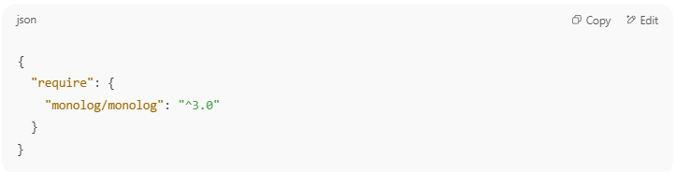
{
"require": {
"monolog/monolog": "^3.0"
}
}

2. You run:
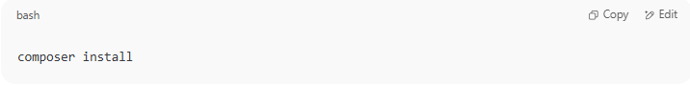
composer install

3. Composer:
  - Downloads Monolog and its required dependencies
  - Puts them in a vendor/ folder
  - Creates a composer.lock file to lock versions

✅ Common Composer Commands
# Source: AI Source: Provided by: [Data Path: Persons Table -> ID Column: 1, Name_En Column: Motasem Essam] -> From: [ChatGPT] on [1/26/2026]

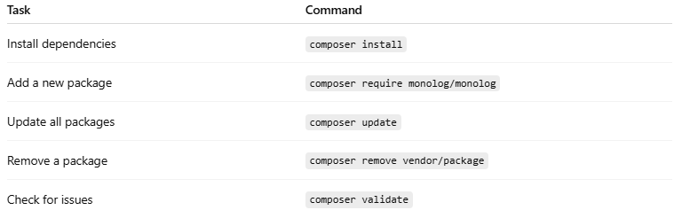

Task | Command
Install dependencies | composer install
Add a new package | composer require monolog/monolog
Update all packages | composer update
Remove a package | composer remove vendor/package
Check for issues | composer validate

📁 Typical Files Composer Uses
# Source: AI Source: Provided by: [Data Path: Persons Table -> ID Column: 1, Name_En Column: Motasem Essam] -> From: [ChatGPT] on [1/26/2026]
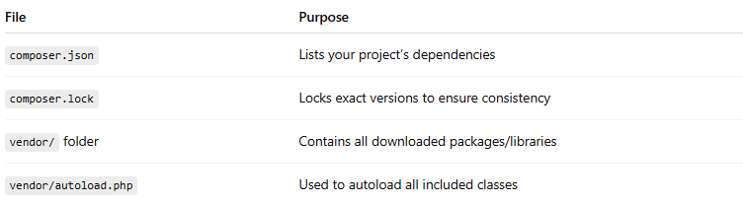

File | Purpose
composer.json | Lists your project’s dependencies
composer.lock | Locks exact versions to ensure consistency
vendor/ folder | Contains all downloaded packages/libraries
vendor/autoload.php | Used to autoload all included classes
You can include this in your PHP:
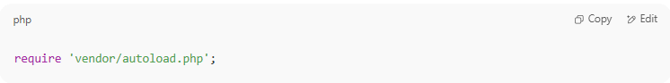
require 'vendor/autoload.php';

🧠 Why Use Composer?
# Source: AI Source: Provided by: [Data Path: Persons Table -> ID Column: 1, Name_En Column: Motasem Essam] -> From: [ChatGPT] on [1/26/2026]
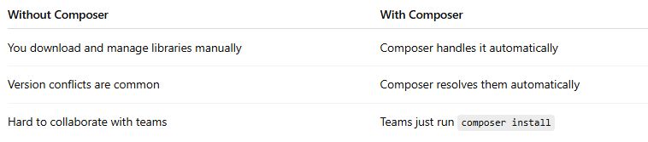

Without Composer | With Composer
You download and manage libraries manually | Composer handles it automatically
Version conflicts are common | Composer resolves them automatically
Hard to collaborate with teams | Teams just run composer install

Composer CLI

💻 What Is Composer CLI?
# Source: AI Source: Provided by: [Data Path: Persons Table -> ID Column: 1, Name_En Column: Motasem Essam] -> From: [ChatGPT] on [1/26/2026]
Composer CLI (Command Line Interface) is the tool you use to run Composer commands in your terminal or command prompt to manage PHP dependencies, autoloading, packages, and scripts.
Think of it as the control center for your PHP project setup.

🧰 Composer CLI Is Used For:
# Source: AI Source: Provided by: [Data Path: Persons Table -> ID Column: 1, Name_En Column: Motasem Essam] -> From: [ChatGPT] on [1/26/2026]
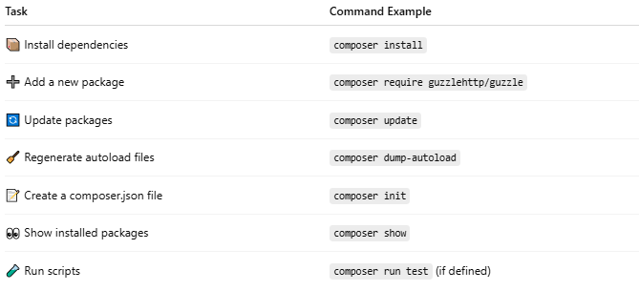

Task | Command Example
📦 Install dependencies | composer install
➕ Add a new package | composer require guzzlehttp/guzzle
🔄 Update packages | composer update
🧹 Regenerate autoload files | composer dump-autoload
📝 Create a composer.json file | composer init
👀 Show installed packages | composer show
🧪 Run scripts | composer run test (if defined)

🔧 Common Composer CLI Commands
# Source: AI Source: Provided by: [Data Path: Persons Table -> ID Column: 1, Name_En Column: Motasem Essam] -> From: [ChatGPT] on [1/26/2026]
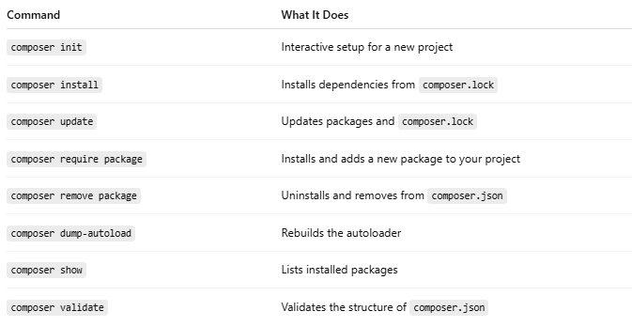

Command | What It Does
composer init | Interactive setup for a new project
composer install | Installs dependencies from composer.lock
composer update | Updates packages and composer.lock
composer require package | Installs and adds a new package to your project
composer remove package | Uninstalls and removes from composer.json
composer dump-autoload | Rebuilds the autoloader
composer show | Lists installed packages
composer validate | Validates the structure of composer.json

🖥️ How to Use It
# Source: AI Source: Provided by: [Data Path: Persons Table -> ID Column: 1, Name_En Column: Motasem Essam] -> From: [ChatGPT] on [1/26/2026]
- Open Terminal (or CMD)
- Go to your project folder:
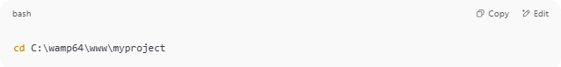
cd C:\wamp64\www\myproject

- Run any Composer command:
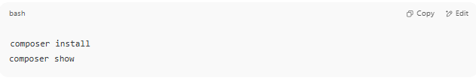
composer install
composer show

If you see this:
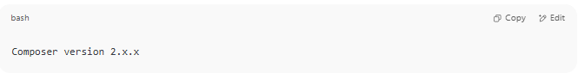
Composer version 2.x.x

Then it's working properly ✅

📦 Example Workflow with Composer CLI
# Source: AI Source: Provided by: [Data Path: Persons Table -> ID Column: 1, Name_En Column: Motasem Essam] -> From: [ChatGPT] on [1/26/2026]
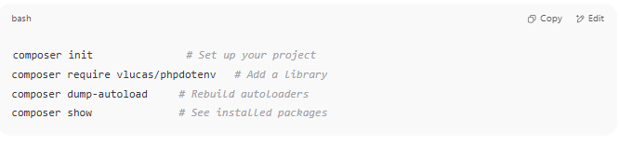
composer init # Set up your project
composer require vlucas/phpdotenv # Add a library
composer dump-autoload # Rebuild autoloaders
composer show # See installed packages

✅ Summary
# Source: AI Source: Provided by: [Data Path: Persons Table -> ID Column: 1, Name_En Column: Motasem Essam] -> From: [ChatGPT] on [1/26/2026]
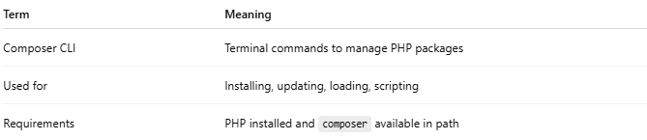

Term | Meaning
Composer CLI | Terminal commands to manage PHP packages
Used for | Installing, updating, loading, scripting
Requirements | PHP installed and composer available in path

composer.json and composer.lock

📄 What Are composer.json and composer.lock in PHP?
# Source: AI Source: Provided by: [Data Path: Persons Table -> ID Column: 1, Name_En Column: Motasem Essam] -> From: [ChatGPT] on [1/26/2026]
These two files work together in Composer, PHP’s dependency manager, to manage your project’s libraries (packages) and ensure consistency across environments.

🔧 composer.json
# Source: AI Source: Provided by: [Data Path: Persons Table -> ID Column: 1, Name_En Column: Motasem Essam] -> From: [ChatGPT] on [1/26/2026]
This is the main configuration file you write or edit.
✅ Purpose:
- Lists the packages your project needs
- Defines autoloading rules
- Includes project metadata (name, author, license, etc.)

🧩 Example:
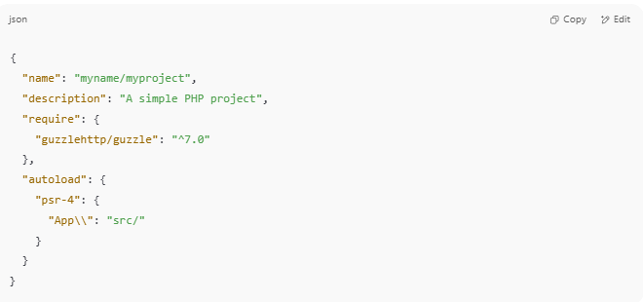
{
"name": "myname/myproject",
"description": "A simple PHP project",
"require": {
"guzzlehttp/guzzle": "^7.0"
},
"autoload": {
"psr-4": {
"App\\": "src/"
}
}
}

✏️ You edit this manually or via:
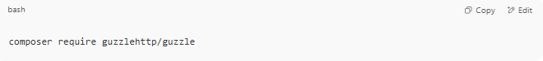
composer require guzzlehttp/guzzle

🛠 Key Sections Explained
# Source: AI Source: Provided by: [Data Path: Persons Table -> ID Column: 1, Name_En Column: Motasem Essam] -> From: [ChatGPT] on [1/26/2026]
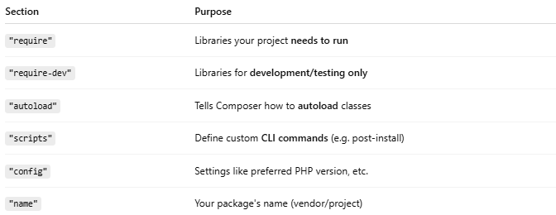

Section | Purpose
"require" | Libraries your project needs to run
"require-dev" | Libraries for development/testing only
"autoload" | Tells Composer how to autoload classes
"scripts" | Define custom CLI commands (e.g. post-install)
"config" | Settings like preferred PHP version, etc.
"name" | Your package's name (vendor/project)

📦 What Are the Uses of name and description in composer.json?
# Source: AI Source: Provided by: [Data Path: Persons Table -> ID Column: 1, Name_En Column: Motasem Essam] -> From: [ChatGPT] on [1/26/2026]
Great question! Let's break it down clearly:

🏷️ "name": Project Identifier
# Source: AI Source: Provided by: [Data Path: Persons Table -> ID Column: 1, Name_En Column: Motasem Essam] -> From: [ChatGPT] on [1/26/2026]
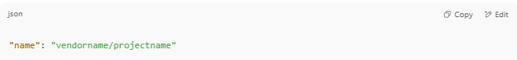
"name": "vendorname/projectname"

✅ Purpose:
- Uniquely identifies your package
- Required if you plan to publish it (on Packagist.org)
- Used for composer require or as a dependency name in other projects
🔍 Example:
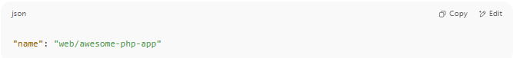
"name": "web/awesome-php-app"

📌 If another project wants to use your package, they'd write:
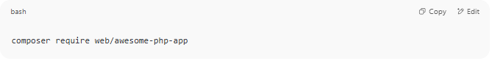
composer require web/awesome-php-app

📝 "description": Human-readable Info
# Source: AI Source: Provided by: [Data Path: Persons Table -> ID Column: 1, Name_En Column: Motasem Essam] -> From: [ChatGPT] on [1/26/2026]
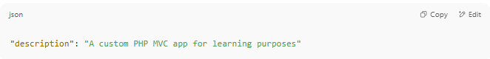
"description": "A custom PHP MVC app for learning purposes"

✅ Purpose:
- Provides a summary of what your project does
- Appears in:
  - composer show
  - Packagist.org listings
  - GitHub or IDE tools that parse composer.json
- Helps developers quickly understand your project

👤 What Is the Use of "authors" in composer.json?
# Source: AI Source: Provided by: [Data Path: Persons Table -> ID Column: 1, Name_En Column: Motasem Essam] -> From: [ChatGPT] on [1/26/2026]
The "authors" section in composer.json is used to document the people or teams who created or maintain the project. It’s optional but highly recommended, especially for open-source or team projects.
📄 Format of "authors"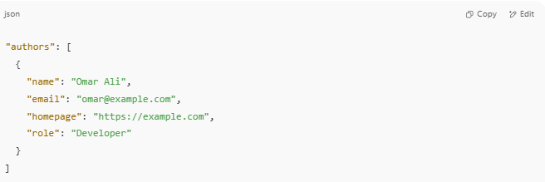
"authors": [
{
"name": "Omar Ali",
"email": "omar@example.com",
"homepage": "https://example.com",
"role": "Developer"
}
]

Only "name" is required — the rest are optional.

✅ Why Use "authors"?
# Source: AI Source: Provided by: [Data Path: Persons Table -> ID Column: 1, Name_En Column: Motasem Essam] -> From: [ChatGPT] on [1/26/2026]
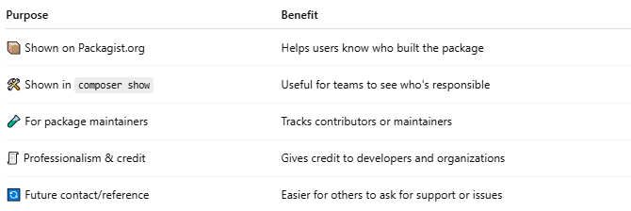

Purpose | Benefit
📦 Shown on Packagist.org | Helps users know who built the package
🛠 Shown in composer show | Useful for teams to see who's responsible
🧪 For package maintainers | Tracks contributors or maintainers
🧾 Professionalism & credit | Gives credit to developers and organizations
🔄 Future contact/reference | Easier for others to ask for support or issues

🧰 Where It's Used
# Source: AI Source: Provided by: [Data Path: Persons Table -> ID Column: 1, Name_En Column: Motasem Essam] -> From: [ChatGPT] on [1/26/2026]
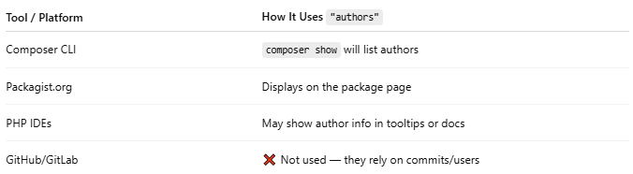

Tool / Platform | How It Uses "authors"
Composer CLI | composer show will list authors
Packagist.org | Displays on the package page
PHP IDEs | May show author info in tooltips or docs
GitHub/GitLab | ❌ Not used — they rely on commits/users

🧠 Example with Multiple Authors
# Source: AI Source: Provided by: [Data Path: Persons Table -> ID Column: 1, Name_En Column: Motasem Essam] -> From: [ChatGPT] on [1/26/2026]
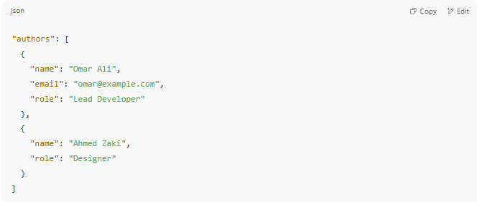
"authors": [
{
"name": "Omar Ali",
"email": "omar@example.com",
"role": "Lead Developer"
},
{
"name": "Ahmed Zaki",
"role": "Designer"
}
]

✅ Summary
# Source: AI Source: Provided by: [Data Path: Persons Table -> ID Column: 1, Name_En Column: Motasem Essam] -> From: [ChatGPT] on [1/26/2026]
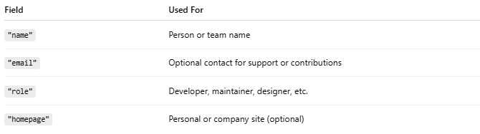

Field | Used For
"name" | Person or team name
"email" | Optional contact for support or contributions
"role" | Developer, maintainer, designer, etc.
"homepage" | Personal or company site (optional)

❓ Does Git Use composer.json Fields Like "name" or "description"?
# Source: AI Source: Provided by: [Data Path: Persons Table -> ID Column: 1, Name_En Column: Motasem Essam] -> From: [ChatGPT] on [1/26/2026]
🔴 No — Git does not use composer.json's name or description fields at all.
Git is only concerned with:
- Tracking file changes (like composer.json itself)
- Managing branches, commits, and versions
- Handling repository hosting (GitHub, GitLab, etc.)

✅ Who Uses composer.json Fields?
# Source: AI Source: Provided by: [Data Path: Persons Table -> ID Column: 1, Name_En Column: Motasem Essam] -> From: [ChatGPT] on [1/26/2026]
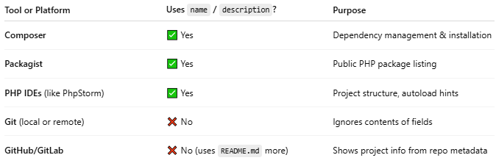

Tool or Platform | Uses name / description? | Purpose
Composer | ✅ Yes | Dependency management & installation
Packagist | ✅ Yes | Public PHP package listing
PHP IDEs (like PhpStorm) | ✅ Yes | Project structure, autoload hints
Git (local or remote) | ❌ No | Ignores contents of fields
GitHub/GitLab | ❌ No (uses README.md more) | Shows project info from repo metadata

🧠 What Git Does Track About Composer
# Source: AI Source: Provided by: [Data Path: Persons Table -> ID Column: 1, Name_En Column: Motasem Essam] -> From: [ChatGPT] on [1/26/2026]
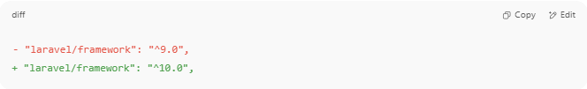
- "laravel/framework": "^9.0",
+ "laravel/framework": "^10.0",

📝 Related Git Best Practices
# Source: AI Source: Provided by: [Data Path: Persons Table -> ID Column: 1, Name_En Column: Motasem Essam] -> From: [ChatGPT] on [1/26/2026]

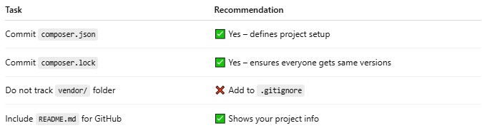

Task | Recommendation
Commit composer.json | ✅ Yes – defines project setup
Commit composer.lock | ✅ Yes – ensures everyone gets same versions
Do not track vendor/ folder | ❌ Add to .gitignore
Include README.md for GitHub | ✅ Shows your project info

✅ Summary
# Source: AI Source: Provided by: [Data Path: Persons Table -> ID Column: 1, Name_En Column: Motasem Essam] -> From: [ChatGPT] on [1/26/2026]
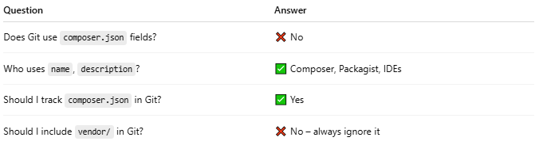

Question | Answer
Does Git use composer.json fields? | ❌ No
Who uses name, description? | ✅ Composer, Packagist, IDEs
Should I track composer.json in Git? | ✅ Yes
Should I include vendor/ in Git? | ❌ No – always ignore it

📌 Summary of Differences
# Source: AI Source: Provided by: [Data Path: Persons Table -> ID Column: 1, Name_En Column: Motasem Essam] -> From: [ChatGPT] on [1/26/2026]
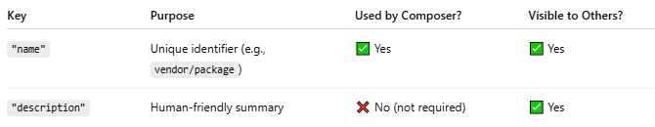
Key | Purpose | Used by Composer? | Visible to Others?
"name" | Unique identifier (e.g., vendor/package) | ✅ Yes | ✅ Yes
"description" | Human-friendly summary | ❌ No (not required) | ✅ Yes

🧠 Real-World Use Cases
# Source: AI Source: Provided by: [Data Path: Persons Table -> ID Column: 1, Name_En Column: Motasem Essam] -> From: [ChatGPT] on [1/26/2026]
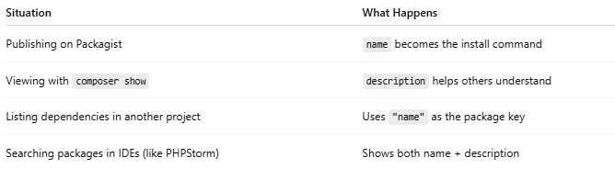

Situation | What Happens
Publishing on Packagist | name becomes the install command
Viewing with composer show | description helps others understand
Listing dependencies in another project | Uses "name" as the package key
Searching packages in IDEs (like PHPStorm) | Shows both name + description

✅ Best Practice Example
# Source: AI Source: Provided by: [Data Path: Persons Table -> ID Column: 1, Name_En Column: Motasem Essam] -> From: [ChatGPT] on [1/26/2026]
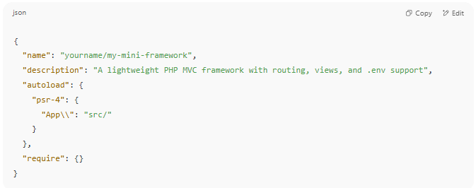

{
"name": "yourname/my-mini-framework",
"description": "A lightweight PHP MVC framework with routing, views, and .env support",
"autoload": {
"psr-4": {
"App\\": "src/"
}
},
"require": {}
}

⚙️ How to Define Custom CLI Commands in Composer (composer.json)
# Source: AI Source: Provided by: [Data Path: Persons Table -> ID Column: 1, Name_En Column: Motasem Essam] -> From: [ChatGPT] on [1/26/2026]
Composer lets you define custom commands using the scripts section in your composer.json. These are usually shell commands or PHP scripts that run when you type:
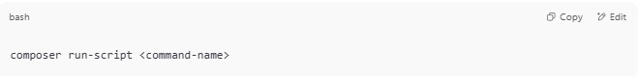
composer run-script <command-name>

🧩 Example: Define Custom CLI Commands

📄 composer.json
# Source: AI Source: Provided by: [Data Path: Persons Table -> ID Column: 1, Name_En Column: Motasem Essam] -> From: [ChatGPT] on [1/26/2026]
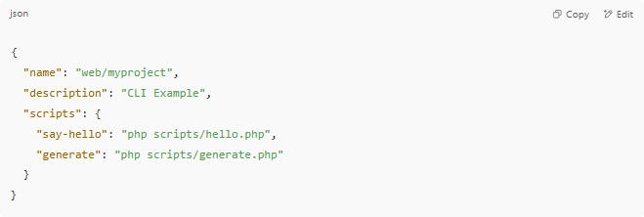
{
"name": "web/myproject",
"description": "CLI Example",
"scripts": {
"say-hello": "php scripts/hello.php",
"generate": "php scripts/generate.php"
}
}

📁 Folder structure
# Source: AI Source: Provided by: [Data Path: Persons Table -> ID Column: 1, Name_En Column: Motasem Essam] -> From: [ChatGPT] on [1/26/2026]
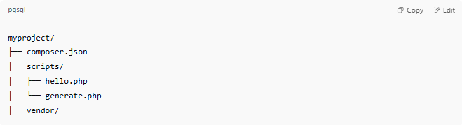
myproject/
├── composer.json
├── scripts/
│ ├── hello.php
│ └── generate.php
├── vendor/

📄 scripts/hello.php
# Source: AI Source: Provided by: [Data Path: Persons Table -> ID Column: 1, Name_En Column: Motasem Essam] -> From: [ChatGPT] on [1/26/2026]
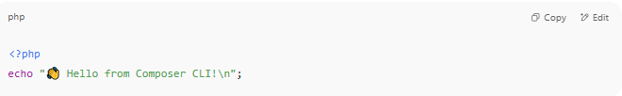
<?php
echo "👋 Hello from Composer CLI!\n";

📄 scripts/generate.php
# Source: AI Source: Provided by: [Data Path: Persons Table -> ID Column: 1, Name_En Column: Motasem Essam] -> From: [ChatGPT] on [1/26/2026]
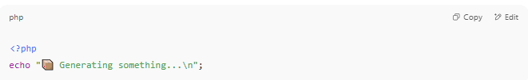
<?php
echo "📦 Generating something...\n";

▶️ Run Your Custom Commands
# Source: AI Source: Provided by: [Data Path: Persons Table -> ID Column: 1, Name_En Column: Motasem Essam] -> From: [ChatGPT] on [1/26/2026]
Use:
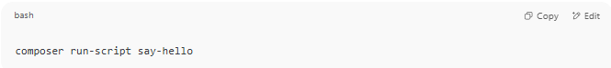
composer run-script say-hello

Or shorter:
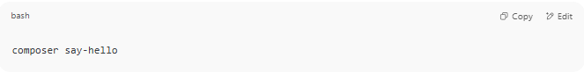
composer say-hello

Output:
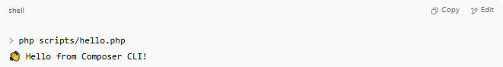
> php scripts/hello.php
👋 Hello from Composer CLI!

🔄 Useful Built-in Composer Events
# Source: AI Source: Provided by: [Data Path: Persons Table -> ID Column: 1, Name_En Column: Motasem Essam] -> From: [ChatGPT] on [1/26/2026]
Besides custom names, you can hook into built-in Composer events like:
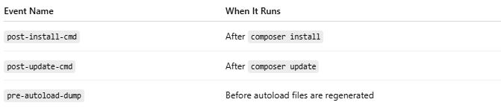
Event Name | When It Runs
post-install-cmd | After composer install
post-update-cmd | After composer update
pre-autoload-dump | Before autoload files are regenerated
Example:
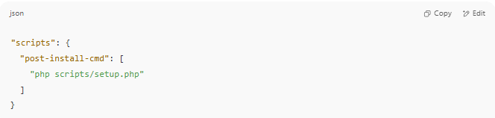
"scripts": {
"post-install-cmd": [
"php scripts/setup.php"
]
}

✅ Summary
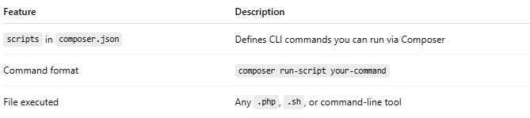

Feature | Description
scripts in composer.json | Defines CLI commands you can run via Composer
Command format | composer run-script your-command
File executed | Any .php, .sh, or command-line tool

📦 composer.lock
# Source: AI Source: Provided by: [Data Path: Persons Table -> ID Column: 1, Name_En Column: Motasem Essam] -> From: [ChatGPT] on [1/26/2026]
This file is auto-generated by Composer.
✅ Purpose:
- Records the exact versions of all installed packages
- Ensures every developer gets identical versions
- Improves reproducibility and stability
🧩 Example Content (simplified):
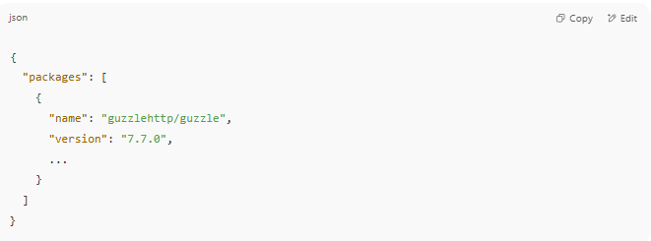
{
"packages": [
{
"name": "guzzlehttp/guzzle",
"version": "7.7.0",
...
}
]
}

⚠️ Do Not Edit It Manually!
Composer updates this file automatically when you run:
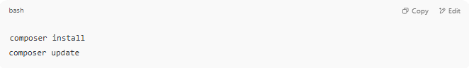
composer install
composer update

🎯 When They Work Together
# Source: AI Source: Provided by: [Data Path: Persons Table -> ID Column: 1, Name_En Column: Motasem Essam] -> From: [ChatGPT] on [1/26/2026]
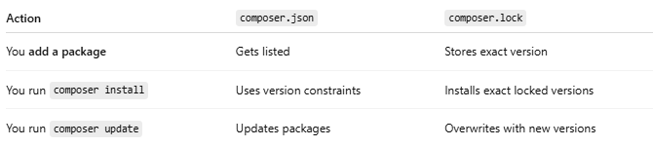

Action | composer.json | composer.lock
You add a package | Gets listed | Stores exact version
You run composer install | Uses version constraints | Installs exact locked versions
You run composer update | Updates packages | Overwrites with new versions

👥 Why Both Are Important
# Source: AI Source: Provided by: [Data Path: Persons Table -> ID Column: 1, Name_En Column: Motasem Essam] -> From: [ChatGPT] on [1/26/2026]
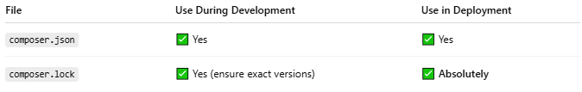

File | Use During Development | Use in Deployment
composer.json | ✅ Yes | ✅ Yes
composer.lock | ✅ Yes (ensure exact versions) | ✅ Absolutely

🔄 Used With Composer Commands
# Source: AI Source: Provided by: [Data Path: Persons Table -> ID Column: 1, Name_En Column: Motasem Essam] -> From: [ChatGPT] on [1/26/2026]
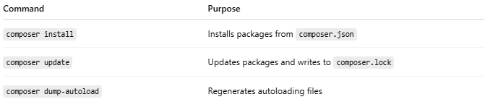

Command | Purpose
composer install | Installs packages from composer.json
composer update | Updates packages and writes to composer.lock
composer dump-autoload | Regenerates autoloading files

📁 Common Files Generated
# Source: AI Source: Provided by: [Data Path: Persons Table -> ID Column: 1, Name_En Column: Motasem Essam] -> From: [ChatGPT] on [1/26/2026]
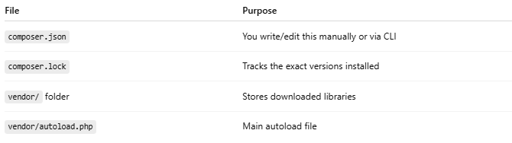

File | Purpose
composer.json | You write/edit this manually or via CLI
composer.lock | Tracks the exact versions installed
vendor/ folder | Stores downloaded libraries
vendor/autoload.php | Main autoload file

✅ Summary
# Source: AI Source: Provided by: [Data Path: Persons Table -> ID Column: 1, Name_En Column: Motasem Essam] -> From: [ChatGPT] on [1/26/2026]
💡 Summary
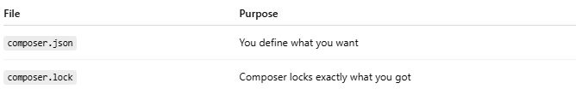

File | Purpose
composer.json | You define what you want
composer.lock | Composer locks exactly what you got
🛡️ Always commit both files to version control (like Git).

🧪 Example in Real PHP App
# Source: AI Source: Provided by: [Data Path: Persons Table -> ID Column: 1, Name_En Column: Motasem Essam] -> From: [ChatGPT] on [1/26/2026]
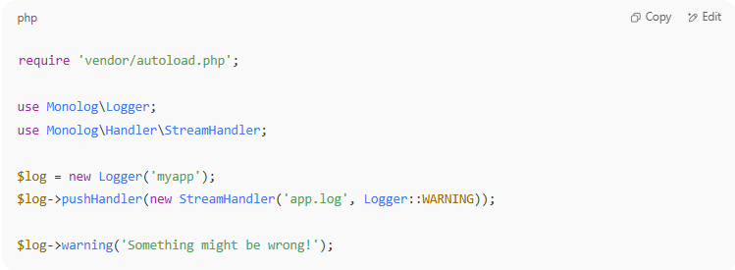

require 'vendor/autoload.php';

use Monolog\Logger;
use Monolog\Handler\StreamHandler;

$log = new Logger('myapp');
$log->pushHandler(new StreamHandler('app.log', Logger::WARNING));

$log->warning('Something might be wrong!');

composer install and composer update
# Source: AI Source: Provided by: [Data Path: Persons Table -> ID Column: 1, Name_En Column: Motasem Essam] -> From: [ChatGPT] on [1/26/2026]
Here's a clear breakdown of the difference between composer install and composer update — two of the most important Composer commands in PHP projects.

🛠️ composer install vs composer update
# Source: AI Source: Provided by: [Data Path: Persons Table -> ID Column: 1, Name_En Column: Motasem Essam] -> From: [ChatGPT] on [1/26/2026]
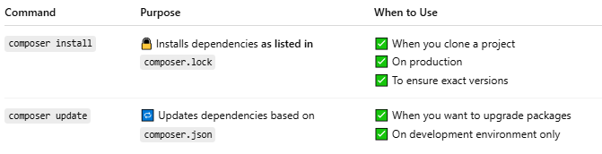
Command | Purpose | When to Use
composer install | 🔒 Installs dependencies as listed in composer.lock | ✅ When you clone a project ✅ On production ✅ To ensure exact versions
composer update | 🔁 Updates dependencies based on composer.json | ✅ When you want to upgrade packages ✅ On development environment only

📦 1. composer install
# Source: AI Source: Provided by: [Data Path: Persons Table -> ID Column: 1, Name_En Column: Motasem Essam] -> From: [ChatGPT] on [1/26/2026]
✅ What it does:
- Reads composer.lock (not composer.json)
- Installs exact versions of dependencies
- Creates vendor/ folder
🧠 Use When:
- Setting up an existing project (git clone)
- Deploying to production
💬 Example:
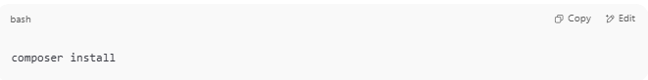
composer install

🔄 2. composer update
# Source: AI Source: Provided by: [Data Path: Persons Table -> ID Column: 1, Name_En Column: Motasem Essam] -> From: [ChatGPT] on [1/26/2026]
✅ What it does:
- Reads composer.json
- Updates to the latest versions allowed by version rules
- Regenerates composer.lock with new versions
🧠 Use When:
- You want to upgrade packages (e.g., to newer versions)
- You added or changed something in composer.json
💬 Example:
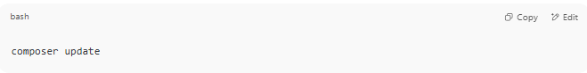
composer update

🧾 Summary Table
# Source: AI Source: Provided by: [Data Path: Persons Table -> ID Column: 1, Name_En Column: Motasem Essam] -> From: [ChatGPT] on [1/26/2026]
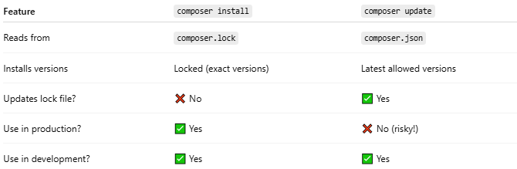
Feature | composer install | composer update
Reads from | composer.lock | composer.json
Installs versions | Locked (exact versions) | Latest allowed versions
Updates lock file? | ❌ No | ✅ Yes
Use in production? | ✅ Yes | ❌ No (risky!)
Use in development? | ✅ Yes | ✅ Yes

🛡️ Tip for Teams
# Source: AI Source: Provided by: [Data Path: Persons Table -> ID Column: 1, Name_En Column: Motasem Essam] -> From: [ChatGPT] on [1/26/2026]
- You commit both composer.json and composer.lock to Git
- This way, your whole team uses the same exact versions
- Run composer install to avoid surprises

Vendor Folder

📁 What Is the vendor/ Folder in PHP (Composer)?
# Source: AI Source: Provided by: [Data Path: Persons Table -> ID Column: 1, Name_En Column: Motasem Essam] -> From: [ChatGPT] on [1/26/2026]
The vendor/ folder is automatically created by Composer and contains:
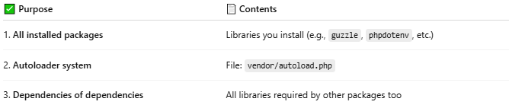
✅ Purpose | 📄 Contents
1. All installed packages | Libraries you install (e.g., guzzle, phpdotenv, etc.)
2. Autoloader system | File: vendor/autoload.php
3. Dependencies of dependencies | All libraries required by other packages too

🧪 Example Contents of vendor/:
# Source: AI Source: Provided by: [Data Path: Persons Table -> ID Column: 1, Name_En Column: Motasem Essam] -> From: [ChatGPT] on [1/26/2026]
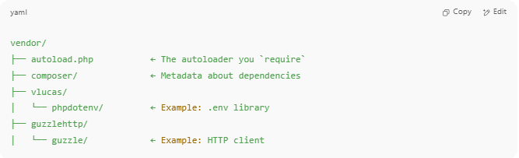
vendor/
├── autoload.php ← The autoloader you `require`
├── composer/ ← Metadata about dependencies
├── vlucas/
│ └── phpdotenv/ ← Example: .env library
├── guzzlehttp/
│ └── guzzle/ ← Example: HTTP client

✅ Why vendor/ Is Important
# Source: AI Source: Provided by: [Data Path: Persons Table -> ID Column: 1, Name_En Column: Motasem Essam] -> From: [ChatGPT] on [1/26/2026]
- It contains the code for every installed PHP package
- It holds the Composer autoloader, so you can do:
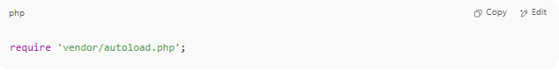
require 'vendor/autoload.php';

- It makes your app modular, so you don’t need to manually include library files

🚫 Do Not Edit vendor/ Yourself
# Source: AI Source: Provided by: [Data Path: Persons Table -> ID Column: 1, Name_En Column: Motasem Essam] -> From: [ChatGPT] on [1/26/2026]
- It’s managed by Composer
- You should never change files manually inside it
- It can always be rebuilt using:
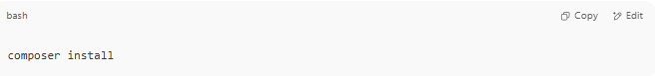
composer install

🧩 Diagram: How vendor/ and autoload.php Work Together
# Source: AI Source: Provided by: [Data Path: Persons Table -> ID Column: 1, Name_En Column: Motasem Essam] -> From: [ChatGPT] on [1/26/2026]
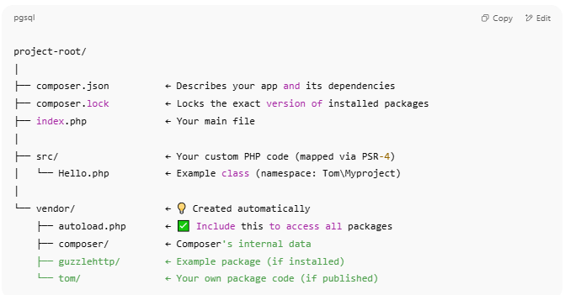
project-root/
│
├── composer.json ← Describes your app and its dependencies
├── composer.lock ← Locks the exact version of installed packages
├── index.php ← Your main file
│
├── src/ ← Your custom PHP code (mapped via PSR-4)
│ └── Hello.php ← Example class (namespace: Tom\Myproject)
│
└── vendor/ ← 💡 Created automatically
├── autoload.php ← ✅ Include this to access all packages
├── composer/ ← Composer's internal data
├── guzzlehttp/ ← Example package (if installed)
└── tom/ ← Your own package code (if published)

📦 Flow:
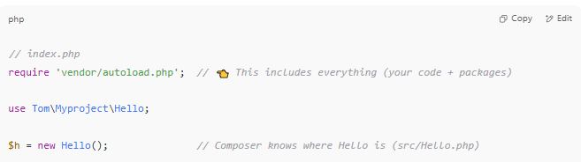
// index.php
require 'vendor/autoload.php'; // 👈 This includes everything (your code + packages)

use Tom\Myproject\Hello;

$h = new Hello(); // Composer knows where Hello is (src/Hello.php)

Recommended .gitignore File
# Source: AI Source: Provided by: [Data Path: Persons Table -> ID Column: 1, Name_En Column: Motasem Essam] -> From: [ChatGPT] on [1/26/2026]
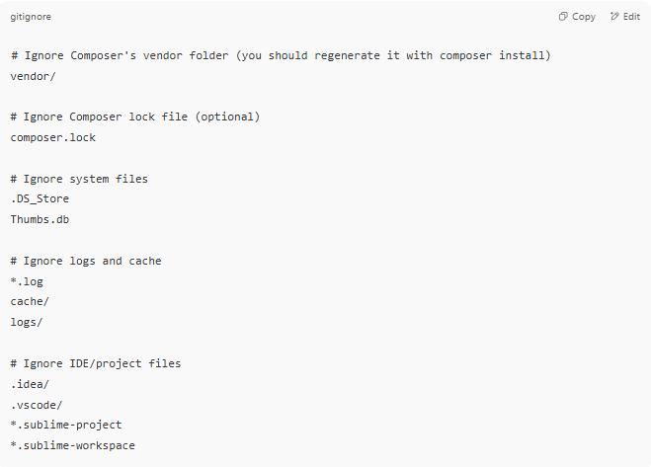
# Ignore Composer's vendor folder (you should regenerate it with composer install)
vendor/

# Ignore Composer lock file (optional)
composer.lock

# Ignore system files
.DS_Store
Thumbs.db

# Ignore logs and cache
*.log
cache/
logs/

# Ignore IDE/project files
.idea/
.vscode/
*.sublime-project
*.sublime-workspace

✅ This .gitignore ensures you don’t commit third-party libraries (like vendor/) to your Git repository — only your code goes in.

🧾 Summary
# Source: AI Source: Provided by: [Data Path: Persons Table -> ID Column: 1, Name_En Column: Motasem Essam] -> From: [ChatGPT] on [1/26/2026]
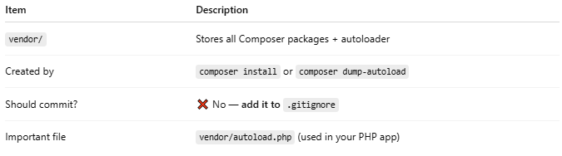

Item | Description
vendor/ | Stores all Composer packages + autoloader
Created by | composer install or composer dump-autoload
Should commit? | ❌ No — add it to .gitignore
Important file | vendor/autoload.php (used in your PHP app)

Src folder

📁 What Is the src/ Folder in PHP Projects?
# Source: AI Source: Provided by: [Data Path: Persons Table -> ID Column: 1, Name_En Column: Motasem Essam] -> From: [ChatGPT] on [1/26/2026]
The src/ folder stands for "source", and it’s a convention (not required) for organizing your own application’s code — such as classes, interfaces, traits, and business logic.

🧩 Typical Usage
# Source: AI Source: Provided by: [Data Path: Persons Table -> ID Column: 1, Name_En Column: Motasem Essam] -> From: [ChatGPT] on [1/26/2026]
When using Composer with PSR-4 autoloading, your composer.json may look like:
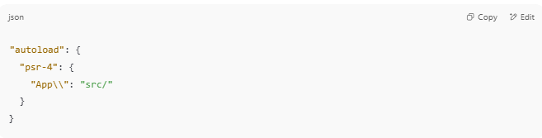
"autoload": {
"psr-4": {
"App\\": "src/"
}
}

This tells Composer:
“Classes in the App\ namespace are located inside the src/ folder.”

🧱 Example Project Structure
# Source: AI Source: Provided by: [Data Path: Persons Table -> ID Column: 1, Name_En Column: Motasem Essam] -> From: [ChatGPT] on [1/26/2026]
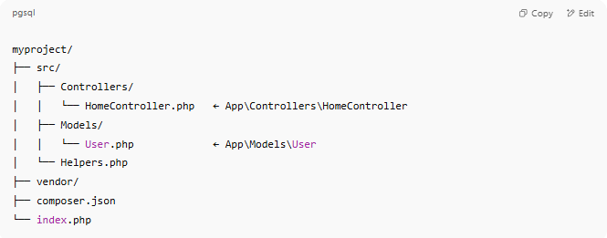
myproject/
├── src/
│ ├── Controllers/
│ │ └── HomeController.php ← App\Controllers\HomeController
│ ├── Models/
│ │ └── User.php ← App\Models\User
│ └── Helpers.php
├── vendor/
├── composer.json
└── index.php

📄 Example Class in src/
# Source: AI Source: Provided by: [Data Path: Persons Table -> ID Column: 1, Name_En Column: Motasem Essam] -> From: [ChatGPT] on [1/26/2026]
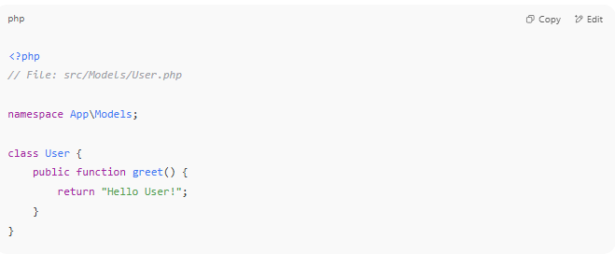
<?php
// File: src/Models/User.php

namespace App\Models;

class User {
public function greet() {
return "Hello User!";
}
}

You can use it in index.php like:
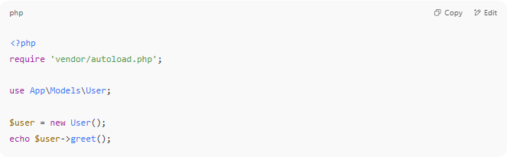
<?php
require 'vendor/autoload.php';

use App\Models\User;

$user = new User();
echo $user->greet();

✅ Why Use src/?
# Source: AI Source: Provided by: [Data Path: Persons Table -> ID Column: 1, Name_En Column: Motasem Essam] -> From: [ChatGPT] on [1/26/2026]
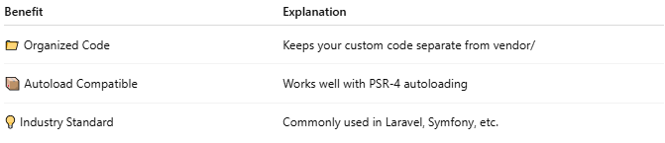

Benefit | Explanation
📁 Organized Code | Keeps your custom code separate from vendor/
📦 Autoload Compatible | Works well with PSR-4 autoloading
💡 Industry Standard | Commonly used in Laravel, Symfony, etc.

🔍 Summary
# Source: AI Source: Provided by: [Data Path: Persons Table -> ID Column: 1, Name_En Column: Motasem Essam] -> From: [ChatGPT] on [1/26/2026]
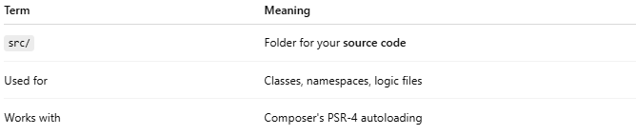

Term | Meaning
src/ | Folder for your source code
Used for | Classes, namespaces, logic files
Works with | Composer's PSR-4 autoloading

Autoloading

I-🔄 What Is Autoloading in PHP?
# Source: AI Source: Provided by: [Data Path: Persons Table -> ID Column: 1, Name_En Column: Motasem Essam] -> From: [ChatGPT] on [1/26/2026]
Autoloading in PHP is a feature that automatically loads class files when they are needed, instead of manually including them with require or include.

II-✅ Simple Definition:
# Source: AI Source: Provided by: [Data Path: Persons Table -> ID Column: 1, Name_En Column: Motasem Essam] -> From: [ChatGPT] on [1/26/2026]
Autoloading lets PHP find and load class files automatically when you use a class — no need to require every file by hand.

III-📦 Without Autoloading:
# Source: AI Source: Provided by: [Data Path: Persons Table -> ID Column: 1, Name_En Column: Motasem Essam] -> From: [ChatGPT] on [1/26/2026]
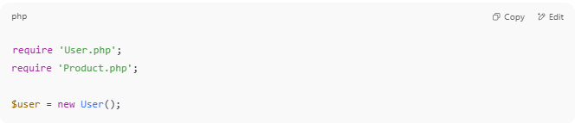
require 'User.php';
require 'Product.php';

$user = new User();

IV-✅ With Autoloading:
# Source: AI Source: Provided by: [Data Path: Persons Table -> ID Column: 1, Name_En Column: Motasem Essam] -> From: [ChatGPT] on [1/26/2026]
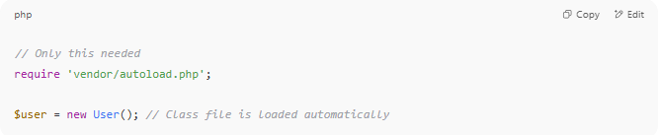
// Only this needed
require 'vendor/autoload.php';

$user = new User(); // Class file is loaded automatically

V-🧠 Why Use Autoloading?
# Source: AI Source: Provided by: [Data Path: Persons Table -> ID Column: 1, Name_En Column: Motasem Essam] -> From: [ChatGPT] on [1/26/2026]
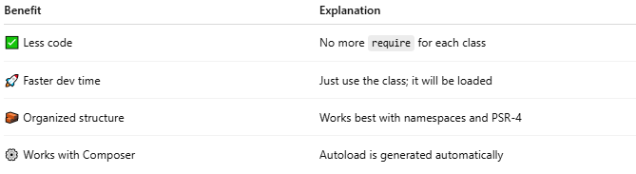
Benefit | Explanation
✅ Less code | No more require for each class
🚀 Faster dev time | Just use the class; it will be loaded
🧱 Organized structure | Works best with namespaces and PSR-4
⚙️ Works with Composer | Autoload is generated automatically

VI-⚙️ Composer Autoloading (PSR-4)
# Source: AI Source: Provided by: [Data Path: Persons Table -> ID Column: 1, Name_En Column: Motasem Essam] -> From: [ChatGPT] on [1/26/2026]
When using Composer, autoloading is handled via the vendor/autoload.php file.
Example composer.json:
# Source: AI Source: Provided by: [Data Path: Persons Table -> ID Column: 1, Name_En Column: Motasem Essam] -> From: [ChatGPT] on [1/26/2026]
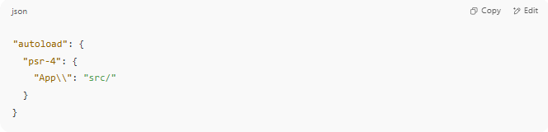
"autoload": {
"psr-4": {
"App\\": "src/"
}
}

Then run:
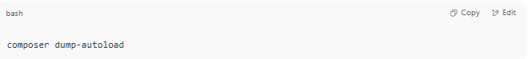
composer dump-autoload

Now PHP will load any class like App\Controller\UserController from:
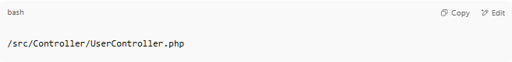
/src/Controller/UserController.php

VII-🔍 How It Works Internally:
# Source: AI Source: Provided by: [Data Path: Persons Table -> ID Column: 1, Name_En Column: Motasem Essam] -> From: [ChatGPT] on [1/26/2026]
PHP uses:
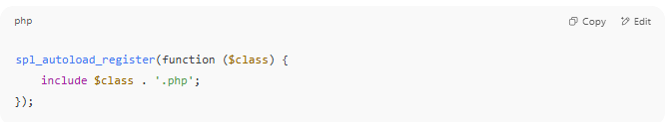
spl_autoload_register(function ($class) {
include $class . '.php';
});

But Composer automates this for you.

VIII-what is composer dump-autoload do

🔁 composer dump-autoload — What Does It Do?
# Source: AI Source: Provided by: [Data Path: Persons Table -> ID Column: 1, Name_En Column: Motasem Essam] -> From: [ChatGPT] on [1/26/2026]
The command:
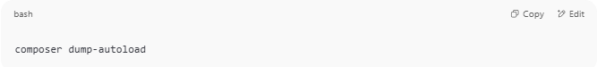
composer dump-autoload

Regenerates Composer's autoloader files so that PHP can automatically load your classes without using require manually.

📂 Why Is This Important?
# Source: AI Source: Provided by: [Data Path: Persons Table -> ID Column: 1, Name_En Column: Motasem Essam] -> From: [ChatGPT] on [1/26/2026]
When you define autoloading in composer.json:
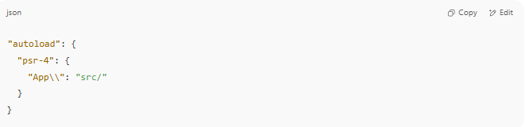
"autoload": {
"psr-4": {
"App\\": "src/"
}
}

Composer uses this rule to map PHP namespaces to file paths.
But for it to work, Composer must generate special files inside the vendor/ directory.

🔧 What composer dump-autoload Does
# Source: AI Source: Provided by: [Data Path: Persons Table -> ID Column: 1, Name_En Column: Motasem Essam] -> From: [ChatGPT] on [1/26/2026]
- Scans the paths you defined in composer.json
- Creates or updates:
  - vendor/autoload.php (main autoload file)
  - vendor/composer/autoload_psr4.php (PSR-4 mappings)
  - vendor/composer/autoload_classmap.php (if needed)
- Enables you to use classes without writing require or include

📌 When Should You Run It?
# Source: AI Source: Provided by: [Data Path: Persons Table -> ID Column: 1, Name_En Column: Motasem Essam] -> From: [ChatGPT] on [1/26/2026]
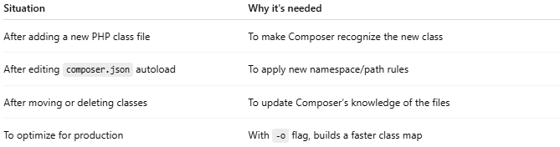

Situation | Why it's needed
After adding a new PHP class file | To make Composer recognize the new class
After editing composer.json autoload | To apply new namespace/path rules
After moving or deleting classes | To update Composer’s knowledge of the files
To optimize for production | With -o flag, builds a faster class map

⚡ Example Command for Production
# Source: AI Source: Provided by: [Data Path: Persons Table -> ID Column: 1, Name_En Column: Motasem Essam] -> From: [ChatGPT] on [1/26/2026]
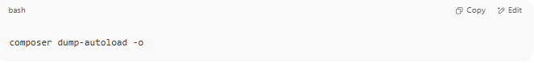
composer dump-autoload -o

- -o = optimize
- Generates a fully optimized class map for faster autoloading (used in live environments)

🧠 Summary
# Source: AI Source: Provided by: [Data Path: Persons Table -> ID Column: 1, Name_En Column: Motasem Essam] -> From: [ChatGPT] on [1/26/2026]
Action | Result
Run composer dump-autoload | Composer rebuilds vendor/autoload.php and mappings
Use autoload in code | require 'vendor/autoload.php'; to enable autoloading

IX-what is autoloader files
# Source: AI Source: Provided by: [Data Path: Persons Table -> ID Column: 1, Name_En Column: Motasem Essam] -> From: [ChatGPT] on [1/26/2026]
Autoloader files are files (generated by Composer) that allow PHP to automatically load your classes without manually writing require or include statements for each file.
They tell PHP:
“If you use this class, I know where to find it.”

⚙️ Main Autoloader File
# Source: AI Source: Provided by: [Data Path: Persons Table -> ID Column: 1, Name_En Column: Motasem Essam] -> From: [ChatGPT] on [1/26/2026]
When you run:
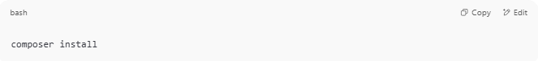
composer install

Or
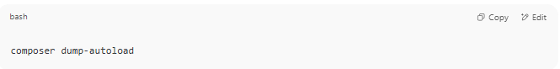
composer dump-autoload

Composer creates the main autoloader file:
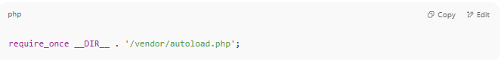
/vendor/autoload.php

You include it once in your project:
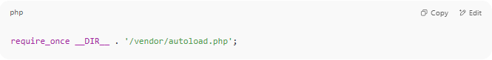
require_once __DIR__ . '/vendor/autoload.php';

And then you can use any class defined in your project or in installed libraries — no manual require.

📁 Composer Autoloader System
# Source: AI Source: Provided by: [Data Path: Persons Table -> ID Column: 1, Name_En Column: Motasem Essam] -> From: [ChatGPT] on [1/26/2026]
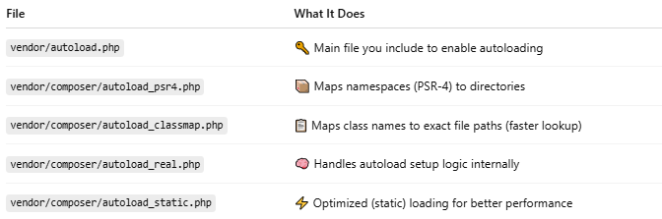
File | What It Does
vendor/autoload.php | 🔑 Main file you include to enable autoloading
vendor/composer/autoload_psr4.php | 📦 Maps namespaces (PSR-4) to directories
vendor/composer/autoload_classmap.php | 📋 Maps class names to exact file paths (faster lookup)
vendor/composer/autoload_real.php | 🧠 Handles autoload setup logic internally
vendor/composer/autoload_static.php | ⚡ Optimized (static) loading for better performance

🧠 Why Use an Autoloader?
# Source: AI Source: Provided by: [Data Path: Persons Table -> ID Column: 1, Name_En Column: Motasem Essam] -> From: [ChatGPT] on [1/26/2026]
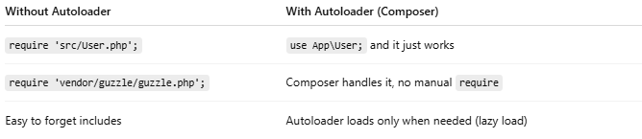

Without Autoloader | With Autoloader (Composer)
require 'src/User.php'; | use App\User; and it just works
require 'vendor/guzzle/guzzle.php'; | Composer handles it, no manual require
Easy to forget includes | Autoloader loads only when needed (lazy load)

✅ Benefits
# Source: AI Source: Provided by: [Data Path: Persons Table -> ID Column: 1, Name_En Column: Motasem Essam] -> From: [ChatGPT] on [1/26/2026]
- 💡 Cleaner code (no manual includes)
- ⚡ Loads only what you use (on demand)
- 📚 Integrates with 3rd-party packages
- 🚀 Faster setup for modern PHP apps

📌 Summary
# Source: AI Source: Provided by: [Data Path: Persons Table -> ID Column: 1, Name_En Column: Motasem Essam] -> From: [ChatGPT] on [1/26/2026]
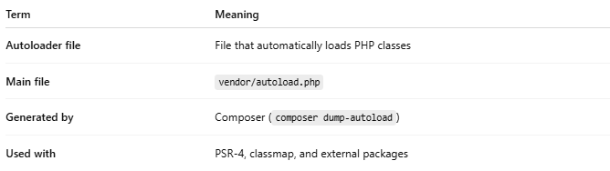

Term | Meaning
Autoloader file | File that automatically loads PHP classes
Main file | vendor/autoload.php
Generated by | Composer (composer dump-autoload)
Used with | PSR-4, classmap, and external packages

X-📘 What Is PSR-4?
# Source: AI Source: Provided by: [Data Path: Persons Table -> ID Column: 1, Name_En Column: Motasem Essam] -> From: [ChatGPT] on [1/26/2026]
PSR-4 stands for PHP Standard Recommendation #4 — a modern standard for autoloading PHP classes using namespaces and directory structure.
It was created by the PHP-FIG (PHP Framework Interop Group).

✅ Simple Definition:
# Source: AI Source: Provided by: [Data Path: Persons Table -> ID Column: 1, Name_En Column: Motasem Essam] -> From: [ChatGPT] on [1/26/2026]
PSR-4 defines how to map a PHP class name (with namespaces) to a file path on disk — so autoloaders like Composer can find and load it automatically.

📁 Example

Class:
# Source: AI Source: Provided by: [Data Path: Persons Table -> ID Column: 1, Name_En Column: Motasem Essam] -> From: [ChatGPT] on [1/26/2026]
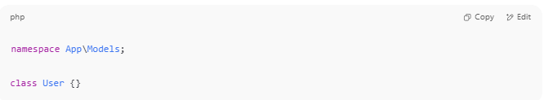
namespace App\Models;

class User {}

File Path (PSR-4):
# Source: AI Source: Provided by: [Data Path: Persons Table -> ID Column: 1, Name_En Column: Motasem Essam] -> From: [ChatGPT] on [1/26/2026]
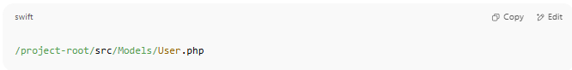
/project-root/src/Models/User.php

Composer.json:
# Source: AI Source: Provided by: [Data Path: Persons Table -> ID Column: 1, Name_En Column: Motasem Essam] -> From: [ChatGPT] on [1/26/2026]
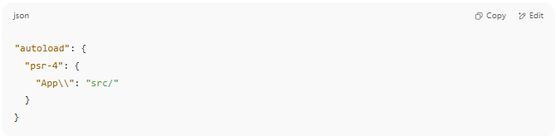
"autoload": {
"psr-4": {
"App\\": "src/"
}
}

After running:
# Source: AI Source: Provided by: [Data Path: Persons Table -> ID Column: 1, Name_En Column: Motasem Essam] -> From: [ChatGPT] on [1/26/2026]
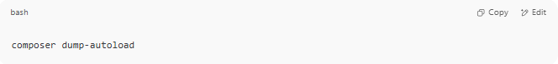
composer dump-autoload

You can use:
# Source: AI Source: Provided by: [Data Path: Persons Table -> ID Column: 1, Name_En Column: Motasem Essam] -> From: [ChatGPT] on [1/26/2026]
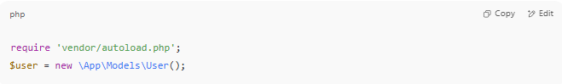
require 'vendor/autoload.php';
$user = new \App\Models\User();

✅ No need to require the file manually.

XI-WHAT IS PSR-4 mappings

🧭 What Is PSR-4 Mapping?
# Source: AI Source: Provided by: [Data Path: Persons Table -> ID Column: 1, Name_En Column: Motasem Essam] -> From: [ChatGPT] on [1/26/2026]
PSR-4 mapping is a rule that tells Composer how to find your PHP classes automatically based on their namespace.
It connects a namespace to a folder path, so Composer can autoload your classes without needing require or include.

📌 PSR-4 = “PHP Standard Recommendation #4”
# Source: AI Source: Provided by: [Data Path: Persons Table -> ID Column: 1, Name_En Column: Motasem Essam] -> From: [ChatGPT] on [1/26/2026]
It defines:
"How to map namespaces to file system directories."

✅ Basic Example of a PSR-4 Mapping
# Source: AI Source: Provided by: [Data Path: Persons Table -> ID Column: 1, Name_En Column: Motasem Essam] -> From: [ChatGPT] on [1/26/2026]
In your composer.json:
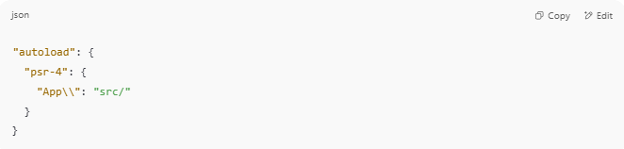
"autoload": {
"psr-4": {
"App\\": "src/"
}
}

🔄 What this means:
# Source: AI Source: Provided by: [Data Path: Persons Table -> ID Column: 1, Name_En Column: Motasem Essam] -> From: [ChatGPT] on [1/26/2026]
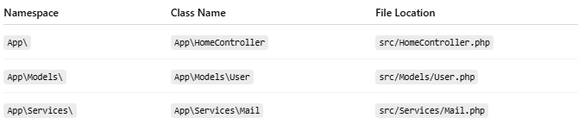

Namespace | Class Name | File Location
App\ | App\HomeController | src/HomeController.php
App\Models\ | App\Models\User | src/Models/User.php
App\Services\ | App\Services\Mail | src/Services/Mail.php
So if you write:
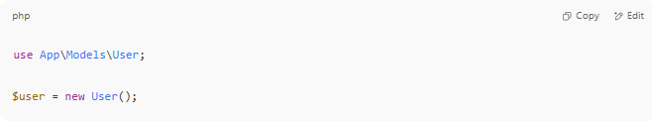
use App\Models\User;

$user = new User();

Composer autoloads the file src/Models/User.php automatically — thanks to the PSR-4 mapping.

🔍 Key Parts of a Mapping
# Source: AI Source: Provided by: [Data Path: Persons Table -> ID Column: 1, Name_En Column: Motasem Essam] -> From: [ChatGPT] on [1/26/2026]
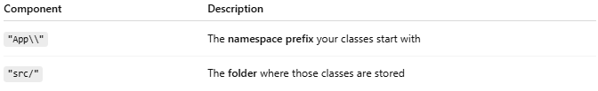

Component | Description
"App\\" | The namespace prefix your classes start with
"src/" | The folder where those classes are stored

🛠 Multiple PSR-4 Mappings
# Source: AI Source: Provided by: [Data Path: Persons Table -> ID Column: 1, Name_En Column: Motasem Essam] -> From: [ChatGPT] on [1/26/2026]
You can define multiple mappings:
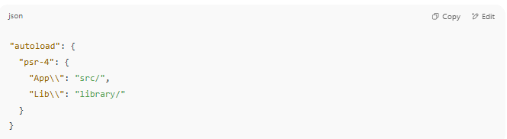
"autoload": {
"psr-4": {
"App\\": "src/",
"Lib\\": "library/"
}
}

This means:
- Classes like App\Controller\Home live in src/Controller/Home.php
- Classes like Lib\Tools\Logger live in library/Tools/Logger.php

🧪 After Adding PSR-4 Mappings
# Source: AI Source: Provided by: [Data Path: Persons Table -> ID Column: 1, Name_En Column: Motasem Essam] -> From: [ChatGPT] on [1/26/2026]
Whenever you define or change PSR-4 mappings:
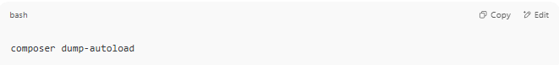
composer dump-autoload

👉 This rebuilds the autoloader files.

✅ Summary
# Source: AI Source: Provided by: [Data Path: Persons Table -> ID Column: 1, Name_En Column: Motasem Essam] -> From: [ChatGPT] on [1/26/2026]
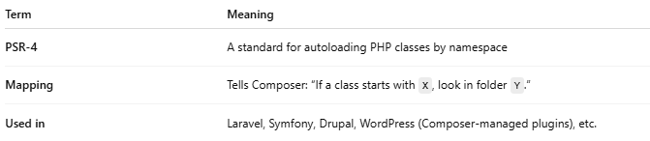

Term | Meaning
PSR-4 | A standard for autoloading PHP classes by namespace
Mapping | Tells Composer: “If a class starts with X, look in folder Y.”
Used in | Laravel, Symfony, Drupal, WordPress (Composer-managed plugins), etc.

XII-🔢 What Was Before PSR-4?
# Source: AI Source: Provided by: [Data Path: Persons Table -> ID Column: 1, Name_En Column: Motasem Essam] -> From: [ChatGPT] on [1/26/2026]
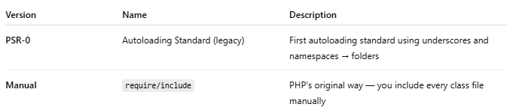
Version | Name | Description
PSR-0 | Autoloading Standard (legacy) | First autoloading standard using underscores and namespaces → folders
Manual | require/include | PHP's original way — you include every class file manually

🆚 PSR-4 vs PSR-0
# Source: AI Source: Provided by: [Data Path: Persons Table -> ID Column: 1, Name_En Column: Motasem Essam] -> From: [ChatGPT] on [1/26/2026]
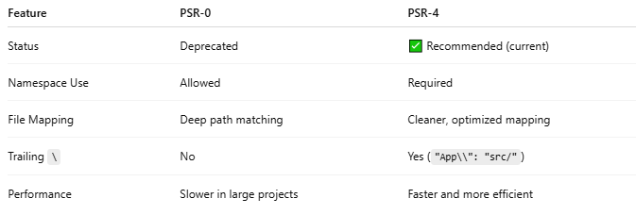

Feature | PSR-0 | PSR-4
Status | Deprecated | ✅ Recommended (current)
Namespace Use | Allowed | Required
File Mapping | Deep path matching | Cleaner, optimized mapping
Trailing \ | No | Yes ("App\\": "src/")
Performance | Slower in large projects | Faster and more efficient

is there other version from PSR-0 and PSR-4
# Source: AI Source: Provided by: [Data Path: Persons Table -> ID Column: 1, Name_En Column: Motasem Essam] -> From: [ChatGPT] on [1/26/2026]
Yes ✅ — in the context of PHP class autoloading, there are only two PSRs that directly relate:

📚 Autoloading Standards
# Source: AI Source: Provided by: [Data Path: Persons Table -> ID Column: 1, Name_En Column: Motasem Essam] -> From: [ChatGPT] on [1/26/2026]
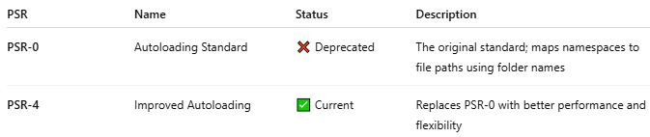

PSR | Name | Status | Description
PSR-0 | Autoloading Standard | ❌ Deprecated | The original standard; maps namespaces to file paths using folder names
PSR-4 | Improved Autoloading | ✅ Current | Replaces PSR-0 with better performance and flexibility

These are the only two PSRs officially related to autoloading.

🔍 What About Other PSRs?
# Source: AI Source: Provided by: [Data Path: Persons Table -> ID Column: 1, Name_En Column: Motasem Essam] -> From: [ChatGPT] on [1/26/2026]
There are many other PSRs, but they cover different topics, such as:
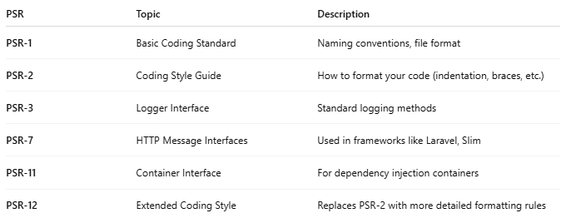

PSR | Topic | Description
PSR-1 | Basic Coding Standard | Naming conventions, file format
PSR-2 | Coding Style Guide | How to format your code (indentation, braces, etc.)
PSR-3 | Logger Interface | Standard logging methods
PSR-7 | HTTP Message Interfaces | Used in frameworks like Laravel, Slim
PSR-11 | Container Interface | For dependency injection containers
PSR-12 | Extended Coding Style | Replaces PSR-2 with more detailed formatting rules

🧾 Summary
# Source: AI Source: Provided by: [Data Path: Persons Table -> ID Column: 1, Name_En Column: Motasem Essam] -> From: [ChatGPT] on [1/26/2026]
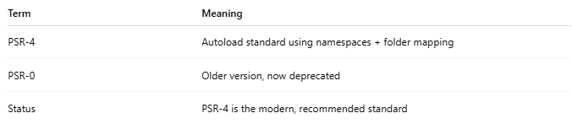

Term | Meaning
PSR-4 | Autoload standard using namespaces + folder mapping
PSR-0 | Older version, now deprecated
Status | PSR-4 is the modern, recommended standard

XIII-🔢 What Was Before PSR-4?
# Source: AI Source: Provided by: [Data Path: Persons Table -> ID Column: 1, Name_En Column: Motasem Essam] -> From: [ChatGPT] on [1/26/2026]

Version | Name | Description
PSR-0 | Autoloading Standard (legacy) | First autoloading standard using underscores and namespaces → folders
Manual | require/include | PHP's original way — you include every class file manually

🆚 PSR-4 vs PSR-0
# Source: AI Source: Provided by: [Data Path: Persons Table -> ID Column: 1, Name_En Column: Motasem Essam] -> From: [ChatGPT] on [1/26/2026]


Feature | PSR-0 | PSR-4
Status | Deprecated | ✅ Recommended (current)
Namespace Use | Allowed | Required
File Mapping | Deep path matching | Cleaner, optimized mapping
Trailing \ | No | Yes ("App\\": "src/")
Performance | Slower in large projects | Faster and more efficient

is there other version from PSR-0 and PSR-4
# Source: AI Source: Provided by: [Data Path: Persons Table -> ID Column: 1, Name_En Column: Motasem Essam] -> From: [ChatGPT] on [1/26/2026]
Yes ✅ — in the context of PHP class autoloading, there are only two PSRs that directly relate:

📚 Autoloading Standards
# Source: AI Source: Provided by: [Data Path: Persons Table -> ID Column: 1, Name_En Column: Motasem Essam] -> From: [ChatGPT] on [1/26/2026]


PSR | Name | Status | Description
PSR-0 | Autoloading Standard | ❌ Deprecated | The original standard; maps namespaces to file paths using folder names
PSR-4 | Improved Autoloading | ✅ Current | Replaces PSR-0 with better performance and flexibility

These are the only two PSRs officially related to autoloading.

🔍 What About Other PSRs?
# Source: AI Source: Provided by: [Data Path: Persons Table -> ID Column: 1, Name_En Column: Motasem Essam] -> From: [ChatGPT] on [1/26/2026]
There are many other PSRs, but they cover different topics, such as:


PSR | Topic | Description
PSR-1 | Basic Coding Standard | Naming conventions, file format
PSR-2 | Coding Style Guide | How to format your code (indentation, braces, etc.)
PSR-3 | Logger Interface | Standard logging methods
PSR-7 | HTTP Message Interfaces | Used in frameworks like Laravel, Slim
PSR-11 | Container Interface | For dependency injection containers
PSR-12 | Extended Coding Style | Replaces PSR-2 with more detailed formatting rules

🧾 Summary
# Source: AI Source: Provided by: [Data Path: Persons Table -> ID Column: 1, Name_En Column: Motasem Essam] -> From: [ChatGPT] on [1/26/2026]


Term | Meaning
PSR-4 | Autoload standard using namespaces + folder mapping
PSR-0 | Older version, now deprecated
Status | PSR-4 is the modern, recommended standard

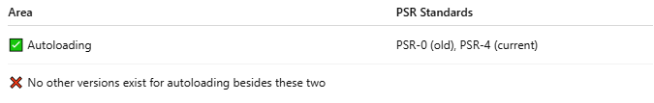

Area | PSR Standards
✅ Autoloading | PSR-0 (old), PSR-4 (current)
❌ No other versions exist for autoloading besides these two

XIV-what is PHP-FIG

🏛️ What Is PHP-FIG?
# Source: AI Source: Provided by: [Data Path: Persons Table -> ID Column: 1, Name_En Column: Motasem Essam] -> From: [ChatGPT] on [1/26/2026]
PHP-FIG stands for PHP Framework Interop Group.

✅ Simple Definition:
# Source: AI Source: Provided by: [Data Path: Persons Table -> ID Column: 1, Name_En Column: Motasem Essam] -> From: [ChatGPT] on [1/26/2026]
PHP-FIG is a group of developers from major PHP frameworks and libraries who create shared standards (called PSRs) to make PHP code more consistent and interoperable.

🧠 Purpose of PHP-FIG:
# Source: AI Source: Provided by: [Data Path: Persons Table -> ID Column: 1, Name_En Column: Motasem Essam] -> From: [ChatGPT] on [1/26/2026]
To solve this problem:
🔁 "Why do Symfony, Laravel, and Zend all structure or log things differently?"
By defining common rules, PHP-FIG helps different frameworks "talk the same language" — so libraries can work together smoothly.

📜 What PHP-FIG Does:
# Source: AI Source: Provided by: [Data Path: Persons Table -> ID Column: 1, Name_En Column: Motasem Essam] -> From: [ChatGPT] on [1/26/2026]
It creates PSRs — PHP Standards Recommendations — that define best practices.
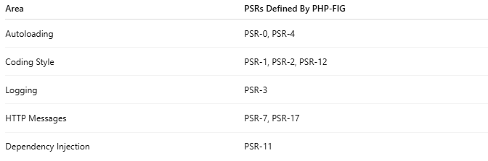
Area | PSRs Defined By PHP-FIG
Autoloading | PSR-0, PSR-4
Coding Style | PSR-1, PSR-2, PSR-12
Logging | PSR-3
HTTP Messages | PSR-7, PSR-17
Dependency Injection | PSR-11

👥 Who's in PHP-FIG?
# Source: AI Source: Provided by: [Data Path: Persons Table -> ID Column: 1, Name_En Column: Motasem Essam] -> From: [ChatGPT] on [1/26/2026]
- Representatives from major frameworks:
  - Symfony
  - Laravel
  - Zend (Laminas)
  - Yii
  - Drupal
  - Composer
  - And more...
They vote and agree on standards together.

🔄 How It Works:
# Source: AI Source: Provided by: [Data Path: Persons Table -> ID Column: 1, Name_En Column: Motasem Essam] -> From: [ChatGPT] on [1/26/2026]
- A proposal is made for a new standard (e.g., PSR-4 for autoloading).
- It goes through review, voting, and approval.
- If accepted, it becomes an official PSR.

🔗 Official Website:
# Source: AI Source: Provided by: [Data Path: Persons Table -> ID Column: 1, Name_En Column: Motasem Essam] -> From: [ChatGPT] on [1/26/2026]
https://www.php-fig.org/

🕓 Timeline of Major PSRs
# Source: AI Source: Provided by: [Data Path: Persons Table -> ID Column: 1, Name_En Column: Motasem Essam] -> From: [ChatGPT] on [1/26/2026]
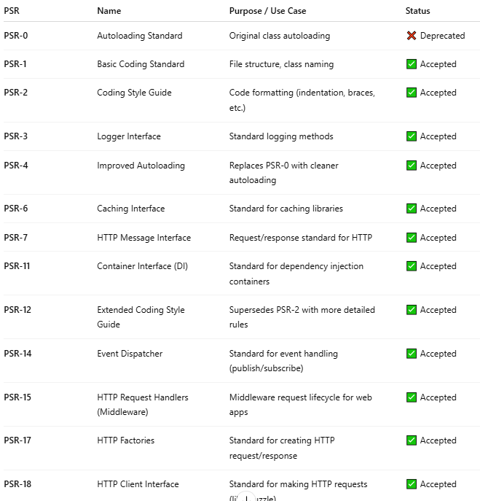

PSR | Name | Purpose / Use Case | Status
PSR-0 | Autoloading Standard | Original class autoloading | ❌ Deprecated
PSR-1 | Basic Coding Standard | File structure, class naming | ✅ Accepted
PSR-2 | Coding Style Guide | Code formatting (indentation, braces, etc.) | ✅ Accepted
PSR-3 | Logger Interface | Standard logging methods | ✅ Accepted
PSR-4 | Improved Autoloading | Replaces PSR-0 with cleaner autoloading | ✅ Accepted
PSR-6 | Caching Interface | Standard for caching libraries | ✅ Accepted
PSR-7 | HTTP Message Interface | Request/response standard for HTTP | ✅ Accepted
PSR-11 | Container Interface (DI) | Standard for dependency injection containers | ✅ Accepted
PSR-12 | Extended Coding Style Guide | Supersedes PSR-2 with more detailed rules | ✅ Accepted
PSR-14 | Event Dispatcher | Standard for event handling (publish/subscribe) | ✅ Accepted
PSR-15 | HTTP Request Handlers (Middleware) | Middleware request lifecycle for web apps | ✅ Accepted
PSR-17 | HTTP Factories | Standard for creating HTTP request/response | ✅ Accepted
PSR-18 | HTTP Client Interface | Standard for making HTTP requests (like Guzzle) | ✅ Accepted

✅ Most Useful PSRs for Developers Today
# Source: AI Source: Provided by: [Data Path: Persons Table -> ID Column: 1, Name_En Column: Motasem Essam] -> From: [ChatGPT] on [1/26/2026]
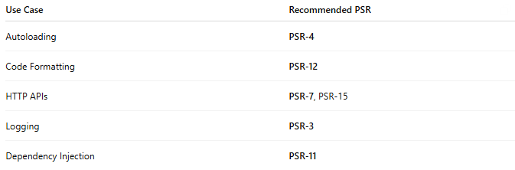

Use Case | Recommended PSR
Autoloading | PSR-4
Code Formatting | PSR-12
HTTP APIs | PSR-7, PSR-15
Logging | PSR-3
Dependency Injection | PSR-11

🧾 Summary
# Source: AI Source: Provided by: [Data Path: Persons Table -> ID Column: 1, Name_En Column: Motasem Essam] -> From: [ChatGPT] on [1/26/2026]
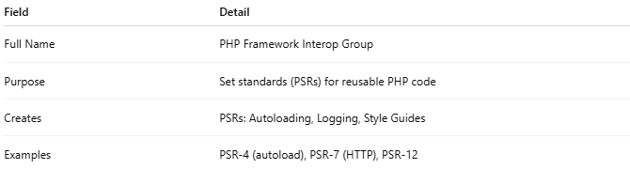

Field | Detail
Full Name | PHP Framework Interop Group
Purpose | Set standards (PSRs) for reusable PHP code
Creates | PSRs: Autoloading, Logging, Style Guides
Examples | PSR-4 (autoload), PSR-7 (HTTP), PSR-12

XV-📍 Where to Include require 'vendor/autoload.php';
# Source: AI Source: Provided by: [Data Path: Persons Table -> ID Column: 1, Name_En Column: Motasem Essam] -> From: [ChatGPT] on [1/26/2026]
You should include:
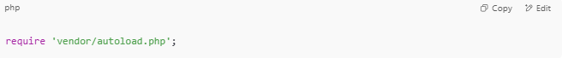
require 'vendor/autoload.php';

at the top of your main entry PHP file — usually the file that starts your application or handles requests.

✅ Common Places to Include It
# Source: AI Source: Provided by: [Data Path: Persons Table -> ID Column: 1, Name_En Column: Motasem Essam] -> From: [ChatGPT] on [1/26/2026]
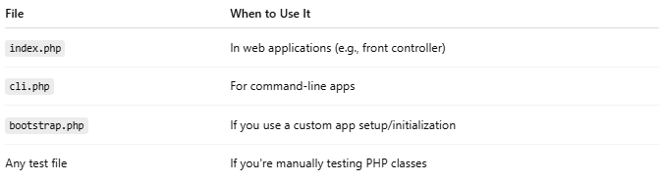

File | When to Use It
index.php | In web applications (e.g., front controller)
cli.php | For command-line apps
bootstrap.php | If you use a custom app setup/initialization
Any test file | If you're manually testing PHP classes

🔁 Example Structure
# Source: AI Source: Provided by: [Data Path: Persons Table -> ID Column: 1, Name_En Column: Motasem Essam] -> From: [ChatGPT] on [1/26/2026]
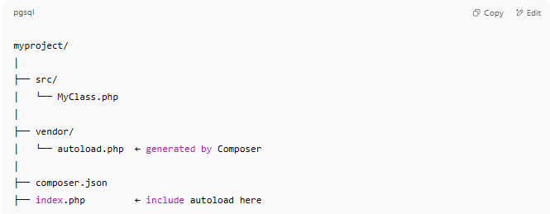
myproject/
│
├── src/
│ └── MyClass.php
│
├── vendor/
│ └── autoload.php ← generated by Composer
│
├── composer.json
├── index.php ← include autoload here

📄 index.php
# Source: AI Source: Provided by: [Data Path: Persons Table -> ID Column: 1, Name_En Column: Motasem Essam] -> From: [ChatGPT] on [1/26/2026]
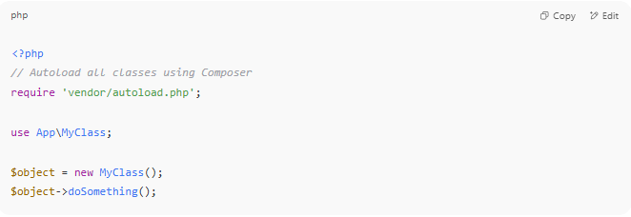
<?php
// Autoload all classes using Composer
require 'vendor/autoload.php';

use App\MyClass;

$object = new MyClass();
$object->doSomething();

Composer’s autoloader now handles all use statements based on your PSR-4 config in composer.json.

❗Important Notes
# Source: AI Source: Provided by: [Data Path: Persons Table -> ID Column: 1, Name_En Column: Motasem Essam] -> From: [ChatGPT] on [1/26/2026]
Make sure you run:
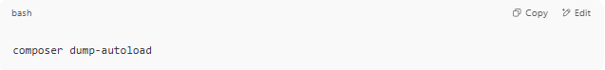
composer dump-autoload
- after creating or updating composer.json or adding classes.

- vendor/autoload.php is generated only after running:
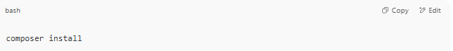
composer install

XVI-🧪 Example: "MyApp" Autoloaded PHP Project
# Source: AI Source: Provided by: [Data Path: Persons Table -> ID Column: 1, Name_En Column: Motasem Essam] -> From: [ChatGPT] on [1/26/2026]
Great! Here's a simple example PHP project using PSR-4 autoloading with Composer. This is how modern PHP projects are structured.

✅ Step 1: Folder Structure
# Source: AI Source: Provided by: [Data Path: Persons Table -> ID Column: 1, Name_En Column: Motasem Essam] -> From: [ChatGPT] on [1/26/2026]
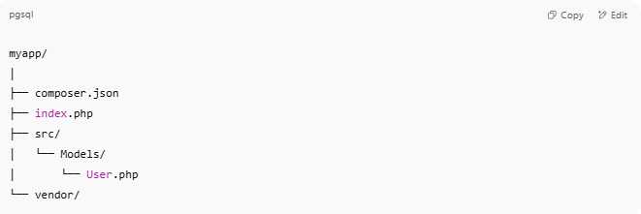
myapp/
│
├── composer.json
├── index.php
├── src/
│ └── Models/
│ └── User.php
└── vendor/

✅ Step 2: Initialize Composer
# Source: AI Source: Provided by: [Data Path: Persons Table -> ID Column: 1, Name_En Column: Motasem Essam] -> From: [ChatGPT] on [1/26/2026]
In your project folder:
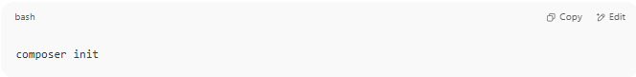
composer init

Answer the prompts, then when asked:
Add PSR-4 autoload mapping?
Enter:
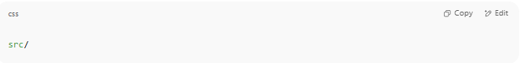
src/

✅ Step 3: composer.json
# Source: AI Source: Provided by: [Data Path: Persons Table -> ID Column: 1, Name_En Column: Motasem Essam] -> From: [ChatGPT] on [1/26/2026]
Make sure it has this:
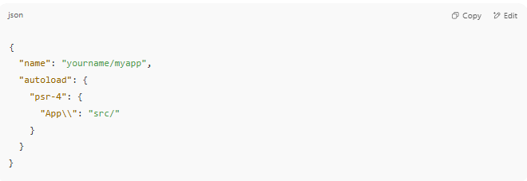
{
"name": "yourname/myapp",
"autoload": {
"psr-4": {
"App\\": "src/"
}
}
}

Then run:
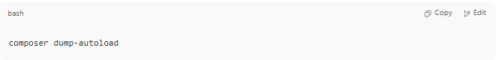
composer dump-autoload

✅ Step 4: Create a Class
# Source: AI Source: Provided by: [Data Path: Persons Table -> ID Column: 1, Name_En Column: Motasem Essam] -> From: [ChatGPT] on [1/26/2026]
📄 src/Models/User.php
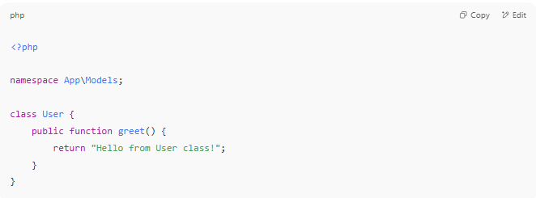
<?php

namespace App\Models;

class User {
public function greet() {
return "Hello from User class!";
}
}

✅ Step 5: Use the Class
# Source: AI Source: Provided by: [Data Path: Persons Table -> ID Column: 1, Name_En Column: Motasem Essam] -> From: [ChatGPT] on [1/26/2026]
📄 index.php
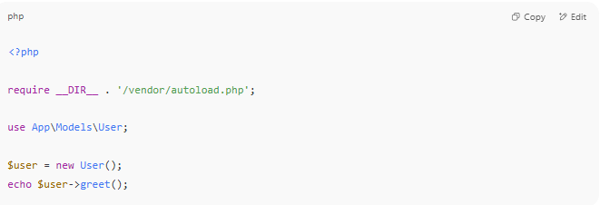
<?php

require __DIR__ . '/vendor/autoload.php';

use App\Models\User;

$user = new User();
echo $user->greet();

✅ Step 6: Run the Project
# Source: AI Source: Provided by: [Data Path: Persons Table -> ID Column: 1, Name_En Column: Motasem Essam] -> From: [ChatGPT] on [1/26/2026]
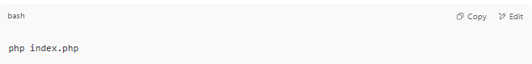
php index.php

✅ Output:
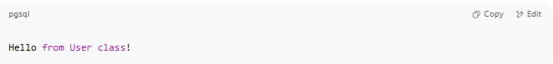
Hello from User class!

🧾 Summary
# Source: AI Source: Provided by: [Data Path: Persons Table -> ID Column: 1, Name_En Column: Motasem Essam] -> From: [ChatGPT] on [1/26/2026]
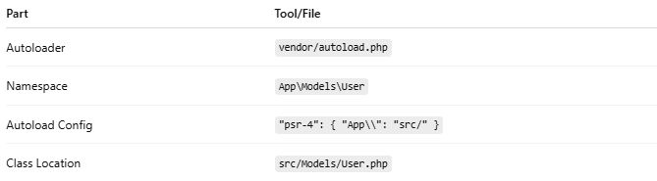

Part | Tool/File
Autoloader | vendor/autoload.php
Namespace | App\Models\User
Autoload Config | "psr-4": { "App\\": "src/" }
Class Location | src/Models/User.php

XVII-🧾 Summary
# Source: AI Source: Provided by: [Data Path: Persons Table -> ID Column: 1, Name_En Column: Motasem Essam] -> From: [ChatGPT] on [1/26/2026]
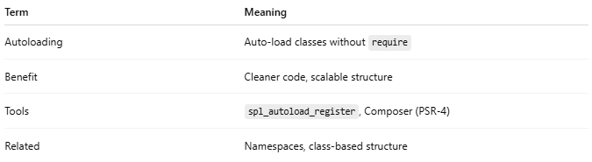

Term | Meaning
Autoloading | Auto-load classes without require
Benefit | Cleaner code, scalable structure
Tools | spl_autoload_register, Composer (PSR-4)
Related | Namespaces, class-based structure

composer init

🛠️ What Does composer init Do?
# Source: AI Source: Provided by: [Data Path: Persons Table -> ID Column: 1, Name_En Column: Motasem Essam] -> From: [ChatGPT] on [1/26/2026]
The command:

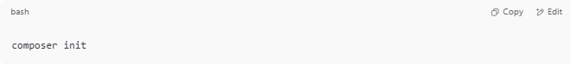
composer init

Creates a new composer.json file for your PHP project by guiding you through a step-by-step interactive setup.

📋 What It Does
# Source: AI Source: Provided by: [Data Path: Persons Table -> ID Column: 1, Name_En Column: Motasem Essam] -> From: [ChatGPT] on [1/26/2026]
- Asks you questions like:
  - 📛 Package name (e.g. yourname/project)
  - 📝 Description
  - 🏷️ License
  - 👤 Author info
  - 💾 Dependencies (libraries you want to require)
- Then generates a ready-to-use composer.json

✅ When to Use composer init
# Source: AI Source: Provided by: [Data Path: Persons Table -> ID Column: 1, Name_En Column: Motasem Essam] -> From: [ChatGPT] on [1/26/2026]
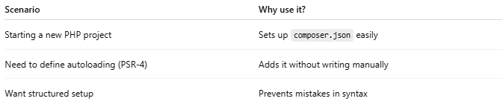

Scenario | Why use it?
Starting a new PHP project | Sets up composer.json easily
Need to define autoloading (PSR-4) | Adds it without writing manually
Want structured setup | Prevents mistakes in syntax

📌 What to Do After
- Add classes in your defined folder (src/, for example)
- Run:
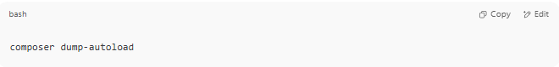
composer dump-autoload

- Include the autoloader in your code:
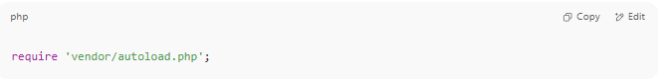
require 'vendor/autoload.php';

Guide Steps

1. Create folder
# Source: AI Source: Provided by: [Data Path: Persons Table -> ID Column: 1, Name_En Column: Motasem Essam] -> From: [ChatGPT] on [1/26/2026]
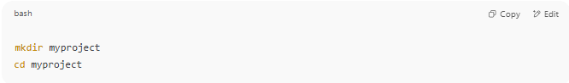
mkdir myproject
cd myproject

2.composer init
# Source: AI Source: Provided by: [Data Path: Persons Table -> ID Column: 1, Name_En Column: Motasem Essam] -> From: [ChatGPT] on [1/26/2026]
Then inside the folder:
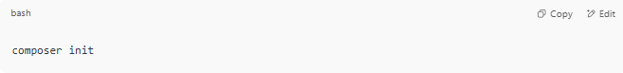
Just press Enter for defaults.

🧾 1. Package Name
# Source: AI Source: Provided by: [Data Path: Persons Table -> ID Column: 1, Name_En Column: Motasem Essam] -> From: [ChatGPT] on [1/26/2026]
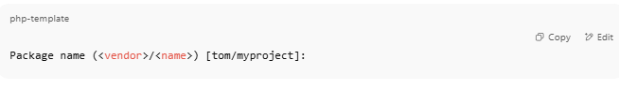Package name (<vendor>/<name>) [tom/myproject]:

This should follow the format:
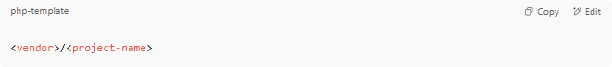
<vendor>/<project-name>

✅ Example:
- omar/myproject
- webtools/contact-api
🔸 The vendor is usually your GitHub username, organization name, or your name in lowercase.
🔸 The name is your project folder name or app name (also lowercase, no spaces).
You can press Enter to accept the default:
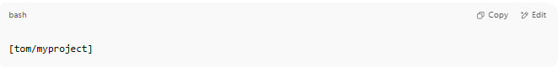
[tom/myproject]

Or type your own:
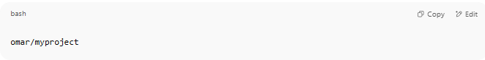
omar/myproject

📝 2. Description
# Source: AI Source: Provided by: [Data Path: Persons Table -> ID Column: 1, Name_En Column: Motasem Essam] -> From: [ChatGPT] on [1/26/2026]
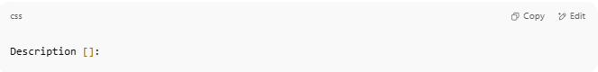
Description []:

This is a short summary of what your project does. It helps other developers understand your package if it’s shared or published later.
✅ Examples:
- A simple PHP API for managing users
- My first PHP web project using Composer
- RESTful web service for managing contacts
- Lightweight blog backend built with PHP
You can also leave it blank by just pressing Enter.

👤3. Author
# Source: AI Source: Provided by: [Data Path: Persons Table -> ID Column: 1, Name_En Column: Motasem Essam] -> From: [ChatGPT] on [1/26/2026]
This is where you define who created the package. It uses this format: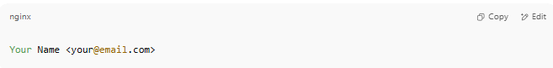

✅ Examples:
- Omar Ali <omar@example.com>
- Web Dev <webdev@gmail.com>
If you're okay with the existing default:
Just press Enter.

❌ To skip:
Type:
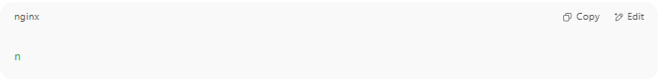
n

🔐 4. Minimum Stability
# Source: AI Source: Provided by: [Data Path: Persons Table -> ID Column: 1, Name_En Column: Motasem Essam] -> From: [ChatGPT] on [1/26/2026]
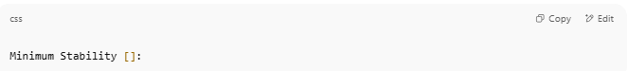
Minimum Stability []:

This tells Composer what level of package stability you're willing to accept when installing dependencies.
🏷️ Stability Levels:
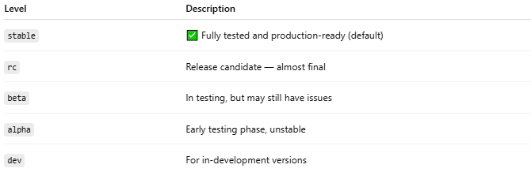

Level | Description
stable | ✅ Fully tested and production-ready (default)
rc | Release candidate — almost final
beta | In testing, but may still have issues
alpha | Early testing phase, unstable
dev | For in-development versions

✅ Recommended:
If you're building a production app, use:
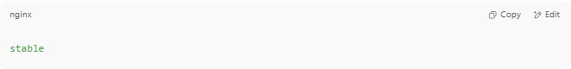
stable

If you're developing and want to try newer or experimental packages, use:

dev

💡 Default:
If you just press Enter, it defaults to stable.
You can still override stability per package later in composer.json.

📦 5. Package Type
# Source: AI Source: Provided by: [Data Path: Persons Table -> ID Column: 1, Name_En Column: Motasem Essam] -> From: [ChatGPT] on [1/26/2026]
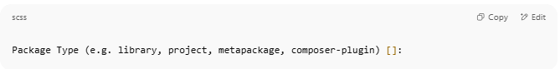
Package Type (e.g. library, project, metapackage, composer-plugin) []:

This defines what kind of package you're creating. Composer uses this to understand how your package should behave.

🧾 Common Types:
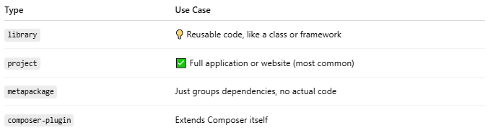

✅ For most PHP apps:
Use:
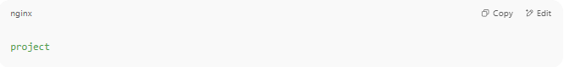
project

If you're creating an app or website (not a reusable library), project is the correct choice.

🧠 You can leave it blank
If you press Enter, Composer won't assign a type — but it's better to specify one for clarity.

📄 6. License
# Source: AI Source: Provided by: [Data Path: Persons Table -> ID Column: 1, Name_En Column: Motasem Essam] -> From: [ChatGPT] on [1/26/2026]
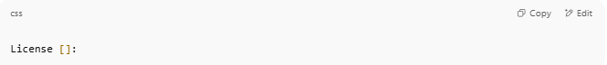
License []:

This defines the terms under which your code can be used. Composer uses it to let others know how they can legally use or share your project.

✅ Common Licenses:
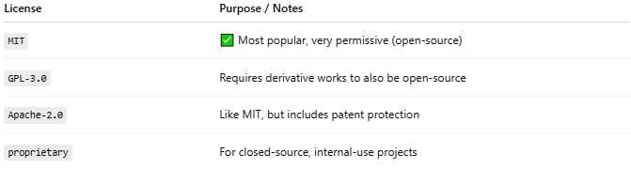

License | Purpose / Notes
MIT | ✅ Most popular, very permissive (open-source)
GPL-3.0 | Requires derivative works to also be open-source
Apache-2.0 | Like MIT, but includes patent protection
proprietary | For closed-source, internal-use projects

📌 Recommendation:
If you're just experimenting or want to share openly:

MIT

If you're building something private or not for sharing: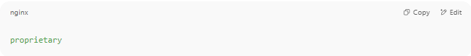
proprietary

❌ You can skip it:
Just press Enter to leave it blank for now.

⚙️ 7. Define Your Dependencies
# Source: AI Source: Provided by: [Data Path: Persons Table -> ID Column: 1, Name_En Column: Motasem Essam] -> From: [ChatGPT] on [1/26/2026]
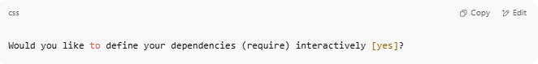
Would you like to define your dependencies (require) interactively [yes]?

This step lets you add PHP packages your project needs — like libraries or frameworks.

✅ Options:
- Type yes or press Enter → Composer will ask you to type the package names.
- Type no if you want to skip for now and add them later manually using composer require.
🧾 Examples of Common Packages:
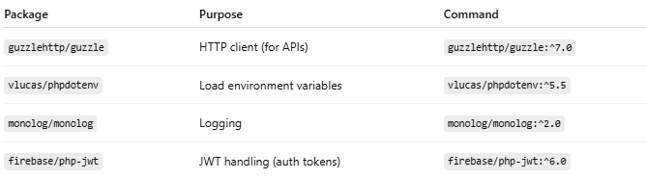

Package | Purpose | Command
guzzlehttp/guzzle | HTTP client (for APIs) | guzzlehttp/guzzle:^7.0
vlucas/phpdotenv | Load environment variables | vlucas/phpdotenv:^5.5
monolog/monolog | Logging | monolog/monolog:^2.0
firebase/php-jwt | JWT handling (auth tokens) | firebase/php-jwt:^6.0

🔍 Example Workflow (if you choose yes):
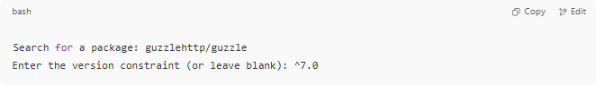
Search for a package: guzzlehttp/guzzle
Enter the version constraint (or leave blank): ^7.0

Repeat for each package you want to add.

📦 If you’re not sure now:
Just type:
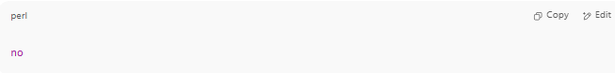
no

You can always add packages later using:
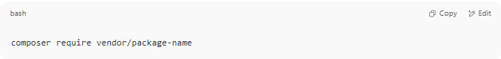
composer require vendor/package-name

🧪 8. Define Development Dependencies
# Source: AI Source: Provided by: [Data Path: Persons Table -> ID Column: 1, Name_En Column: Motasem Essam] -> From: [ChatGPT] on [1/26/2026]

Would you like to define your dev dependencies (require-dev) interactively [yes]?

These are packages needed only during development, not in production.
✅ You can say:
- yes → Composer will ask you to add tools like testing frameworks or linters.
- no → Skip for now; you can add them later with composer require --dev.
🧾 Common Dev Dependencies
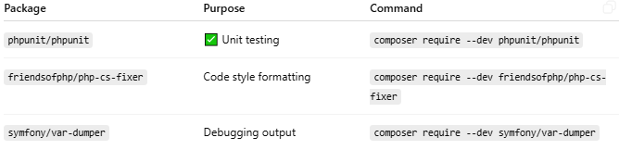

Package | Purpose | Command
phpunit/phpunit | ✅ Unit testing | composer require --dev phpunit/phpunit
friendsofphp/php-cs-fixer | Code style formatting | composer require --dev friendsofphp/php-cs-fixer
symfony/var-dumper | Debugging output | composer require --dev symfony/var-dumper
❌ If you're unsure now:
Just type:

no

📚 9. PSR-4 Autoload Mapping
# Source: AI Source: Provided by: [Data Path: Persons Table -> ID Column: 1, Name_En Column: Motasem Essam] -> From: [ChatGPT] on [1/26/2026]
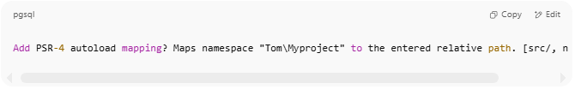
Add PSR-4 autoload mapping? Maps namespace "Tom\Myproject" to the entered relative path. [src/, n to skip]:

This tells Composer how to autoload your PHP classes using PSR-4 — a standard for organizing and loading class files.

✅ What It Means:
If you choose the default:
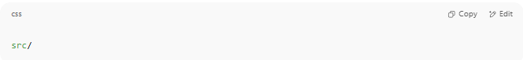
src/

Then any class like:
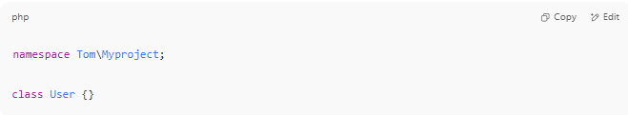
namespace Tom\Myproject;

class User {}

Should be placed in: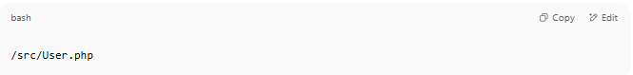
/src/User.php

Composer will autoload it when you run:
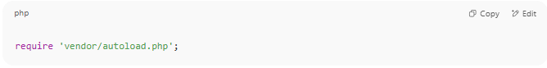
require 'vendor/autoload.php';

✔ Recommended:
If you're building any project with custom classes, keep the default:
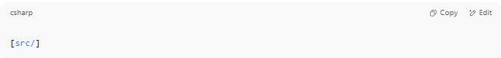
[src/]

❌ To skip:
If you're not using object-oriented PHP or classes:
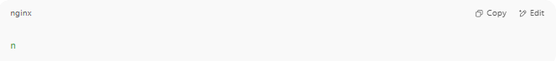
n

You can always add it later manually in composer.json.

📌 Summary Example:
Your composer.json will include:
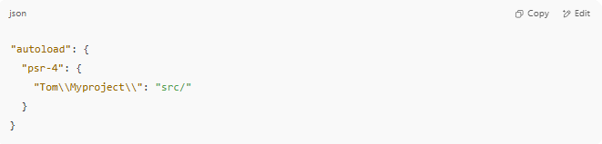
"autoload": {
"psr-4": {
"Tom\\Myproject\\": "src/"
}
}

10. 🟢 Next Step
# Source: AI Source: Provided by: [Data Path: Persons Table -> ID Column: 1, Name_En Column: Motasem Essam] -> From: [ChatGPT] on [1/26/2026]
After you type:
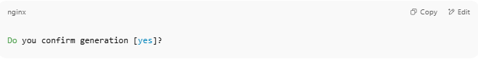
Do you confirm generation [yes]?

Type:
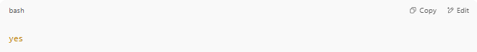
yes

Then run:
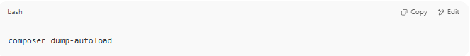
composer dump-autoload

This command will generate the vendor/ folder and the autoloader.

Example
# Source: AI Source: Provided by: [Data Path: Persons Table -> ID Column: 1, Name_En Column: Motasem Essam] -> From: [ChatGPT] on [1/26/2026]
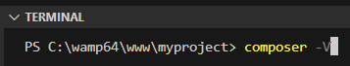
composer -V
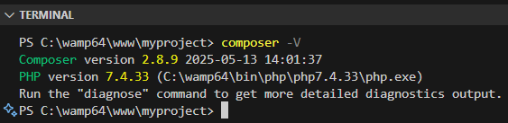
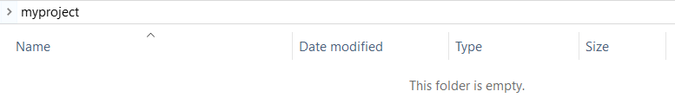
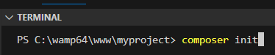
composer init
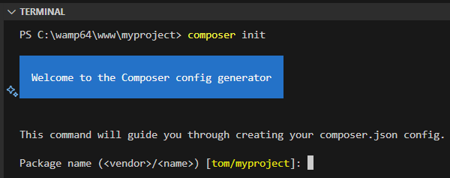
Click enter
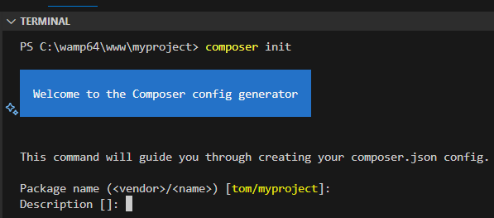
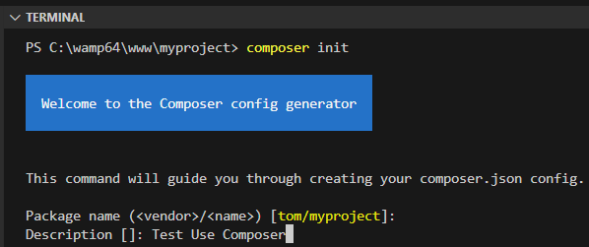
Test use Composer
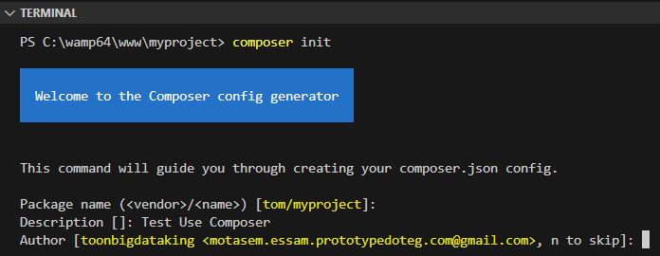
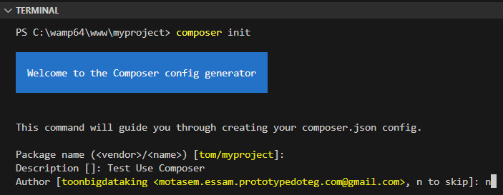
n
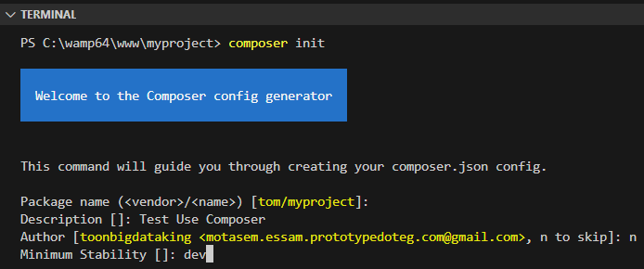
dev

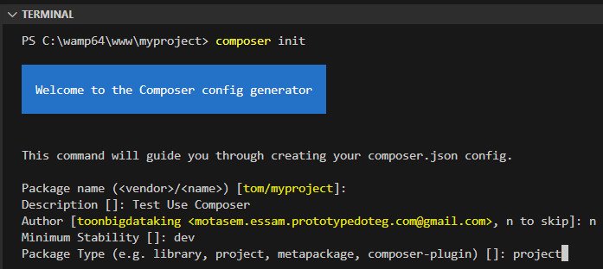
project

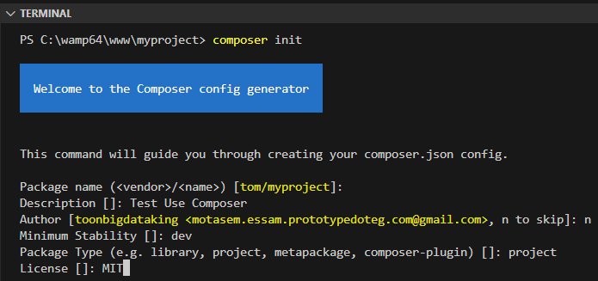
MIT

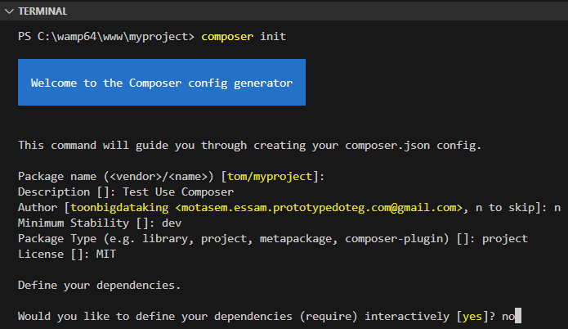
no
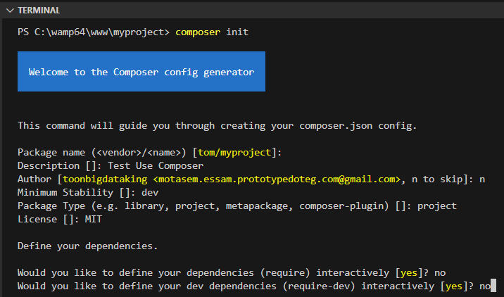
no
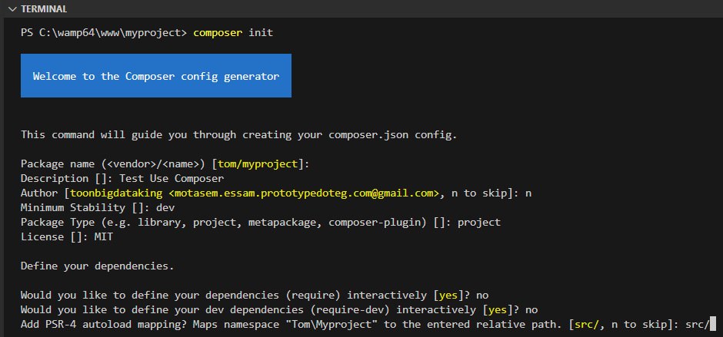
src/
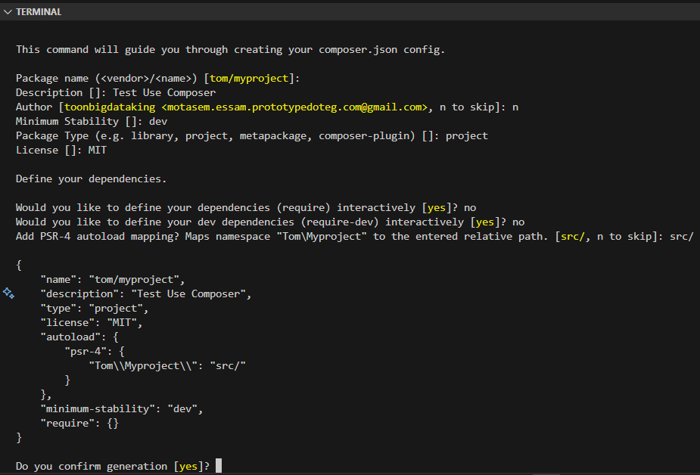
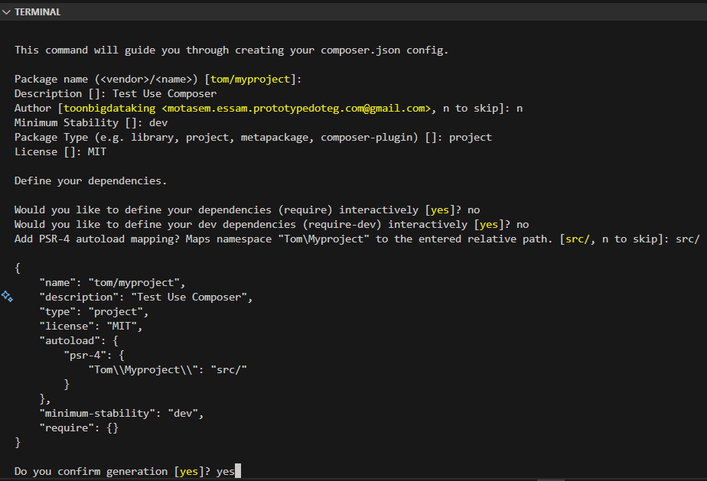
yes
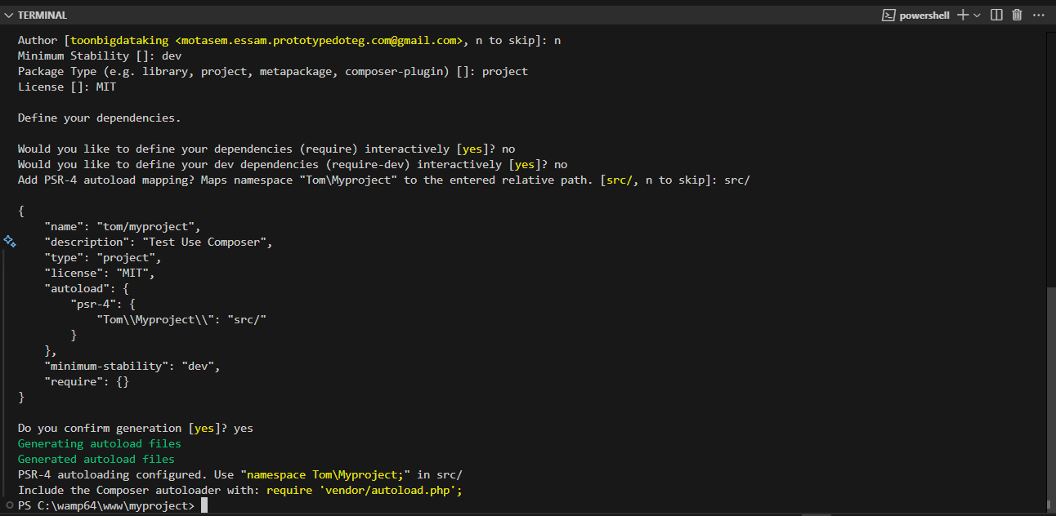
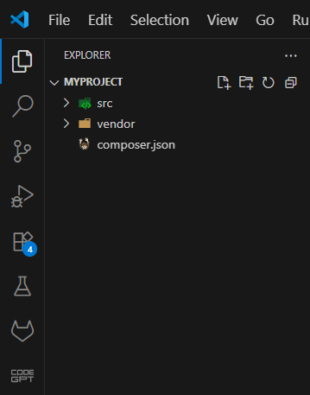
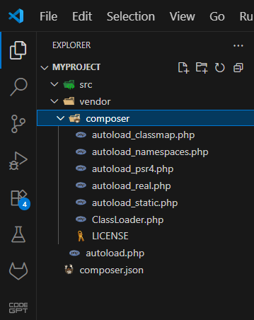

Change compose info After Using composer init

1-🔧 How to Change Project Name
# Source: AI Source: Provided by: [Data Path: Persons Table -> ID Column: 1, Name_En Column: Motasem Essam] -> From: [ChatGPT] on [1/26/2026]
If you used composer init and want to rename your PHP project, you can easily do it by editing your composer.json file manually.

📝 Step-by-Step Instructions

✅ 1. Open composer.json
# Source: AI Source: Provided by: [Data Path: Persons Table -> ID Column: 1, Name_En Column: Motasem Essam] -> From: [ChatGPT] on [1/26/2026]
Locate this section (usually near the top):
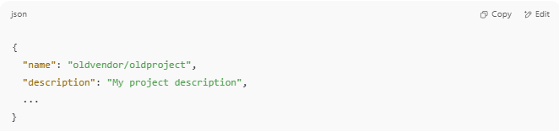
{
"name": "oldvendor/oldproject",
"description": "My project description",
...
}

✏️ 2. Change the "name" Field
# Source: AI Source: Provided by: [Data Path: Persons Table -> ID Column: 1, Name_En Column: Motasem Essam] -> From: [ChatGPT] on [1/26/2026]
Update it to your new project name. Use the format:
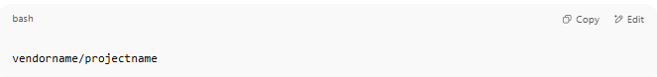
vendorname/projectname

For example:
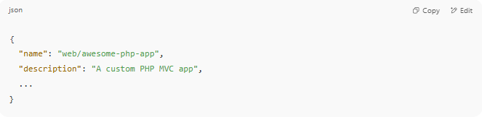
{
"name": "web/awesome-php-app",
"description": "A custom PHP MVC app",
...
}

🔹 vendorname = your GitHub username or org (if applicable)
🔹 projectname = your new project folder/repo name

🔄 3. (Optional) Rename the Folder
# Source: AI Source: Provided by: [Data Path: Persons Table -> ID Column: 1, Name_En Column: Motasem Essam] -> From: [ChatGPT] on [1/26/2026]
If your folder on disk is named incorrectly, rename it in your OS:
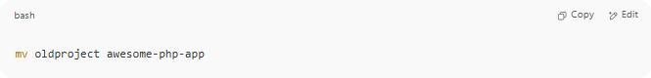
mv oldproject awesome-php-app

Or in Windows: right-click → Rename.

🔁 4. (Optional) Update Autoload Namespace
# Source: AI Source: Provided by: [Data Path: Persons Table -> ID Column: 1, Name_En Column: Motasem Essam] -> From: [ChatGPT] on [1/26/2026]
If you also want to update the PHP namespace (used in src/), edit this section:
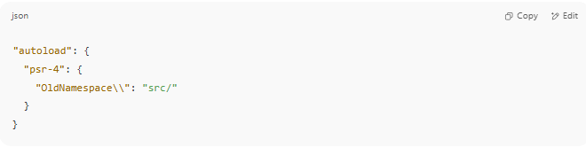
"autoload": {
"psr-4": {
"OldNamespace\\": "src/"
}
}

➡ Change it to your new namespace:
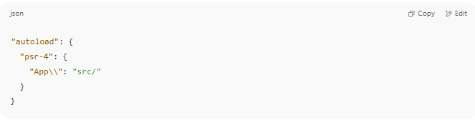
"autoload": {
"psr-4": {
"App\\": "src/"
}
}

Then re-run:
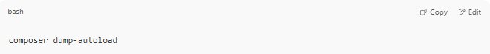
composer dump-autoload

📦 Final composer.json Example
# Source: AI Source: Provided by: [Data Path: Persons Table -> ID Column: 1, Name_En Column: Motasem Essam] -> From: [ChatGPT] on [1/26/2026]
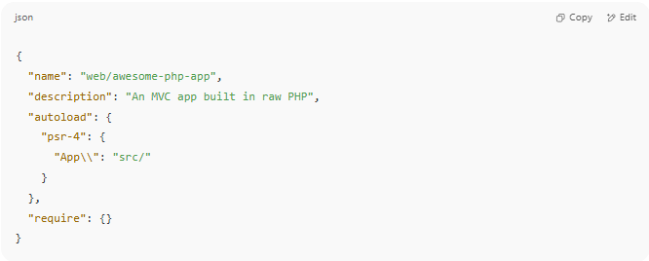

{
"name": "web/awesome-php-app",
"description": "An MVC app built in raw PHP",
"autoload": {
"psr-4": {
"App\\": "src/"
}
},
"require": {}
}

✅ Summary
# Source: AI Source: Provided by: [Data Path: Persons Table -> ID Column: 1, Name_En Column: Motasem Essam] -> From: [ChatGPT] on [1/26/2026]
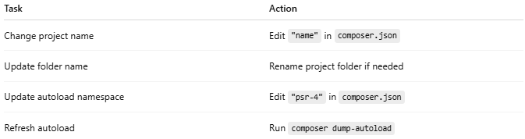
Task | Action
Change project name | Edit "name" in composer.json
Update folder name | Rename project folder if needed
Update autoload namespace | Edit "psr-4" in composer.json
Refresh autoload | Run composer dump-autoload

2-🔧 How to Change Project description
# Source: AI Source: Provided by: [Data Path: Persons Table -> ID Column: 1, Name_En Column: Motasem Essam] -> From: [ChatGPT] on [1/26/2026]
You can easily change the project description by editing the composer.json file.

📝 Step-by-Step Instructions

✅ 1. Open composer.json
# Source: AI Source: Provided by: [Data Path: Persons Table -> ID Column: 1, Name_En Column: Motasem Essam] -> From: [ChatGPT] on [1/26/2026]
Find the line that looks like this:
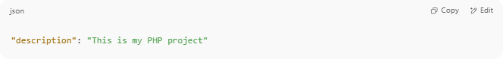
"description": "This is my PHP project"

✏️ 2. Change It to a New Description
# Source: AI Source: Provided by: [Data Path: Persons Table -> ID Column: 1, Name_En Column: Motasem Essam] -> From: [ChatGPT] on [1/26/2026]
Just edit the value of the "description" key:
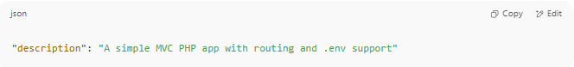
"description": "A simple MVC PHP app with routing and .env support"

✅ You can write anything here — it's for documentation purposes (and used if you publish the package on Packagist or GitHub).

🔄 3. Save the File
# Source: AI Source: Provided by: [Data Path: Persons Table -> ID Column: 1, Name_En Column: Motasem Essam] -> From: [ChatGPT] on [1/26/2026]
No need to run any Composer command after editing the description. It’s just metadata.

📦 Example composer.json (After Update)
# Source: AI Source: Provided by: [Data Path: Persons Table -> ID Column: 1, Name_En Column: Motasem Essam] -> From: [ChatGPT] on [1/26/2026]
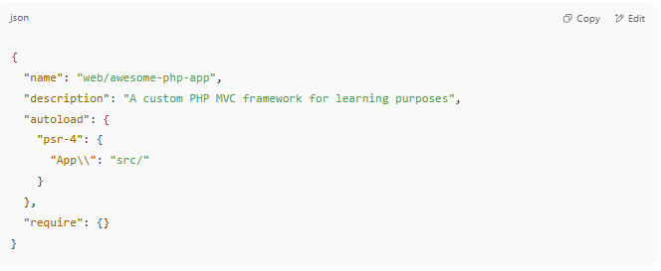

{
"name": "web/awesome-php-app",
"description": "A custom PHP MVC framework for learning purposes",
"autoload": {
"psr-4": {
"App\\": "src/"
}
},
"require": {}
}

✅ Summary
# Source: AI Source: Provided by: [Data Path: Persons Table -> ID Column: 1, Name_En Column: Motasem Essam] -> From: [ChatGPT] on [1/26/2026]
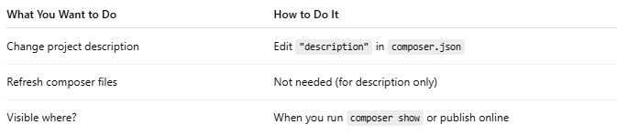

What You Want to Do | How to Do It
Change project description | Edit "description" in composer.json
Refresh composer files | Not needed (for description only)
Visible where? | When you run composer show or publish online

3-🔧 How to Change "authors"
# Source: AI Source: Provided by: [Data Path: Persons Table -> ID Column: 1, Name_En Column: Motasem Essam] -> From: [ChatGPT] on [1/26/2026]
If you already used composer init and want to update the author info, it’s very simple — just manually edit the composer.json file.

✅ Step-by-Step Guide

1. 📝 Open composer.json
# Source: AI Source: Provided by: [Data Path: Persons Table -> ID Column: 1, Name_En Column: Motasem Essam] -> From: [ChatGPT] on [1/26/2026]
Look for this section:
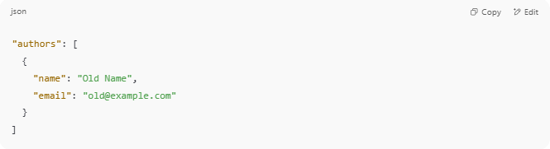
"authors": [
{
"name": "Old Name",
"email": "old@example.com"
}
]

2. ✏️ Edit the Author Info
# Source: AI Source: Provided by: [Data Path: Persons Table -> ID Column: 1, Name_En Column: Motasem Essam] -> From: [ChatGPT] on [1/26/2026]
Change it to your updated name, email, role, or homepage:
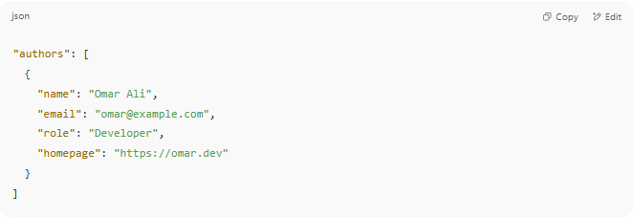
"authors": [
{
"name": "Omar Ali",
"email": "omar@example.com",
"role": "Developer",
"homepage": "https://omar.dev"
}
]

✅ You can add multiple authors as well!

3. 💾 Save the File
# Source: AI Source: Provided by: [Data Path: Persons Table -> ID Column: 1, Name_En Column: Motasem Essam] -> From: [ChatGPT] on [1/26/2026]
No additional command is needed — Composer reads composer.json directly when running commands.

📦 Example Full Section
# Source: AI Source: Provided by: [Data Path: Persons Table -> ID Column: 1, Name_En Column: Motasem Essam] -> From: [ChatGPT] on [1/26/2026]
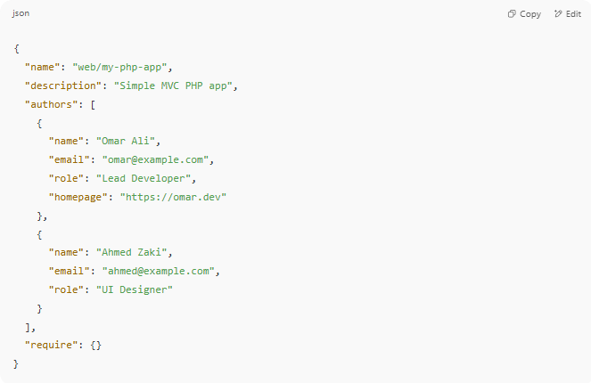
{
"name": "web/my-php-app",
"description": "Simple MVC PHP app",
"authors": [
{
"name": "Omar Ali",
"email": "omar@example.com",
"role": "Lead Developer",
"homepage": "https://omar.dev"
},
{
"name": "Ahmed Zaki",
"email": "ahmed@example.com",
"role": "UI Designer"
}
],
"require": {}
}

🔍 How to View Author Info
# Source: AI Source: Provided by: [Data Path: Persons Table -> ID Column: 1, Name_En Column: Motasem Essam] -> From: [ChatGPT] on [1/26/2026]
You can confirm your authors using:
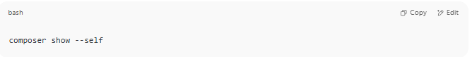
composer show --self

It will show:
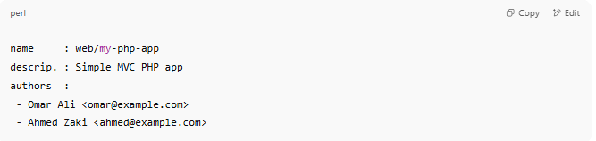
name : web/my-php-app
descrip. : Simple MVC PHP app
authors :
- Omar Ali <omar@example.com>
- Ahmed Zaki <ahmed@example.com>

✅ Summary
# Source: AI Source: Provided by: [Data Path: Persons Table -> ID Column: 1, Name_En Column: Motasem Essam] -> From: [ChatGPT] on [1/26/2026]
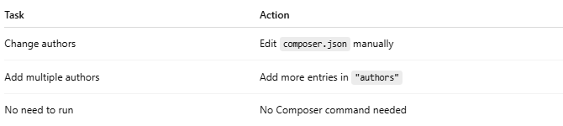

Task | Action
Change authors | Edit composer.json manually
Add multiple authors | Add more entries in "authors"
No need to run | No Composer command needed

4-🔧How to Change Minimum Stability
# Source: AI Source: Provided by: [Data Path: Persons Table -> ID Column: 1, Name_En Column: Motasem Essam] -> From: [ChatGPT] on [1/26/2026]
The minimum-stability option in composer.json controls what type of package versions Composer will allow (stable, beta, dev, etc.).

✅ Step-by-Step: Change minimum-stability
# Source: AI Source: Provided by: [Data Path: Persons Table -> ID Column: 1, Name_En Column: Motasem Essam] -> From: [ChatGPT] on [1/26/2026]
1📝 Open composer.json
Look for (or add) this line:
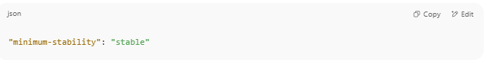
"minimum-stability": "stable"

If it’s not there, you can add it anywhere in the root of the JSON file.

🎯 Valid Stability Levels (from most stable to least):
# Source: AI Source: Provided by: [Data Path: Persons Table -> ID Column: 1, Name_En Column: Motasem Essam] -> From: [ChatGPT] on [1/26/2026]
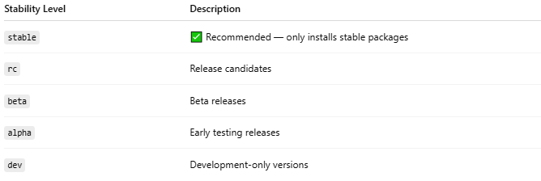
Stability Level | Description
stable | ✅ Recommended — only installs stable packages
rc | Release candidates
beta | Beta releases
alpha | Early testing releases
dev | Development-only versions

🧾 Example: Allow Beta Packages
# Source: AI Source: Provided by: [Data Path: Persons Table -> ID Column: 1, Name_En Column: Motasem Essam] -> From: [ChatGPT] on [1/26/2026]
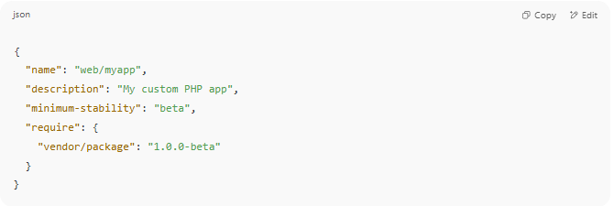
{
"name": "web/myapp",
"description": "My custom PHP app",
"minimum-stability": "beta",
"require": {
"vendor/package": "1.0.0-beta"
}
}

🔐 Optional: Use "prefer-stable": true
# Source: AI Source: Provided by: [Data Path: Persons Table -> ID Column: 1, Name_En Column: Motasem Essam] -> From: [ChatGPT] on [1/26/2026]
This means:
"Try to install stable versions if possible, but allow less stable ones if needed."
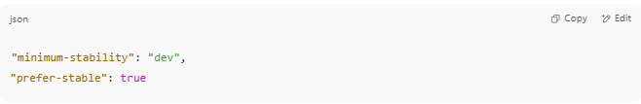
"minimum-stability": "dev",
"prefer-stable": true

🧠 When You Might Need to Change It
# Source: AI Source: Provided by: [Data Path: Persons Table -> ID Column: 1, Name_En Column: Motasem Essam] -> From: [ChatGPT] on [1/26/2026]
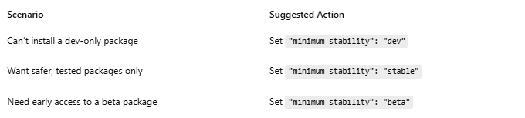
Scenario | Suggested Action
Can't install a dev-only package | Set "minimum-stability": "dev"
Want safer, tested packages only | Set "minimum-stability": "stable"
Need early access to a beta package | Set "minimum-stability": "beta"

🔄 After You Change It
# Source: AI Source: Provided by: [Data Path: Persons Table -> ID Column: 1, Name_En Column: Motasem Essam] -> From: [ChatGPT] on [1/26/2026]
Run:
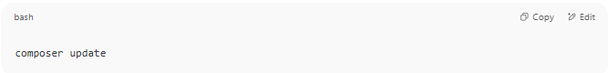
composer update

This will re-evaluate dependencies using the new stability rule.

✅ Summary
# Source: AI Source: Provided by: [Data Path: Persons Table -> ID Column: 1, Name_En Column: Motasem Essam] -> From: [ChatGPT] on [1/26/2026]
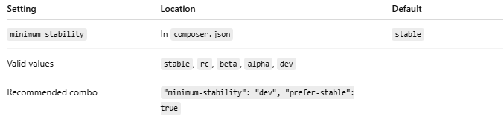
Setting | Location | Default
minimum-stability | In composer.json | stable
Valid values | stable, rc, beta, alpha, dev
Recommended combo | "minimum-stability": "dev", "prefer-stable": true

5-🔧How to Change Package Type
# Source: AI Source: Provided by: [Data Path: Persons Table -> ID Column: 1, Name_En Column: Motasem Essam] -> From: [ChatGPT] on [1/26/2026]
The "type" field in composer.json defines what kind of package your project is — for example, a library, project, composer-plugin, etc.

✅ Step-by-Step: Change the Package Type
# Source: AI Source: Provided by: [Data Path: Persons Table -> ID Column: 1, Name_En Column: Motasem Essam] -> From: [ChatGPT] on [1/26/2026]
📝 Open composer.json
Look for (or add) the type field:
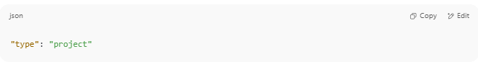
"type": "project"

If it's missing, you can safely add it near the top of the file.

🎯 Common Composer Package Types
# Source: AI Source: Provided by: [Data Path: Persons Table -> ID Column: 1, Name_En Column: Motasem Essam] -> From: [ChatGPT] on [1/26/2026]
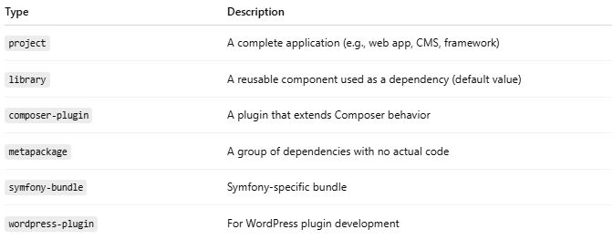

Type | Description
project | A complete application (e.g., web app, CMS, framework)
library | A reusable component used as a dependency (default value)
composer-plugin | A plugin that extends Composer behavior
metapackage | A group of dependencies with no actual code
symfony-bundle | Symfony-specific bundle
wordpress-plugin | For WordPress plugin development

📄 Example Before
# Source: AI Source: Provided by: [Data Path: Persons Table -> ID Column: 1, Name_En Column: Motasem Essam] -> From: [ChatGPT] on [1/26/2026]
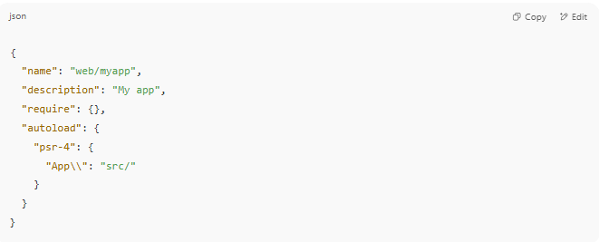

{
"name": "web/myapp",
"description": "My app",
"require": {},
"autoload": {
"psr-4": {
"App\\": "src/"
}
}
}

✅ Example After Adding Type
# Source: AI Source: Provided by: [Data Path: Persons Table -> ID Column: 1, Name_En Column: Motasem Essam] -> From: [ChatGPT] on [1/26/2026]
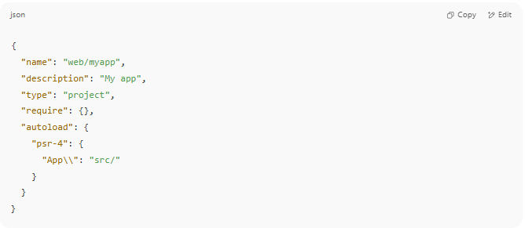
{
"name": "web/myapp",
"description": "My app",
"type": "project",
"require": {},
"autoload": {
"psr-4": {
"App\\": "src/"
}
}
}

🧠 When Should You Change the Type?
# Source: AI Source: Provided by: [Data Path: Persons Table -> ID Column: 1, Name_En Column: Motasem Essam] -> From: [ChatGPT] on [1/26/2026]
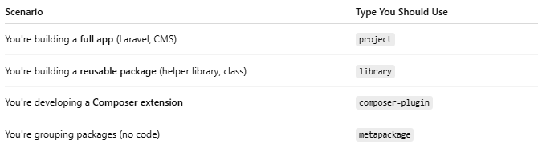

Scenario | Type You Should Use
You're building a full app (Laravel, CMS) | project
You're building a reusable package (helper library, class) | library
You're developing a Composer extension | composer-plugin
You're grouping packages (no code) | metapackage

⚠️ Note:
# Source: AI Source: Provided by: [Data Path: Persons Table -> ID Column: 1, Name_En Column: Motasem Essam] -> From: [ChatGPT] on [1/26/2026]
- The "type" does not affect installation unless you're writing a custom Composer plugin or using install path logic.
- It's mostly for organization, clarity, and tooling support (e.g., Symfony, Packagist).

✅ Summary
# Source: AI Source: Provided by: [Data Path: Persons Table -> ID Column: 1, Name_En Column: Motasem Essam] -> From: [ChatGPT] on [1/26/2026]
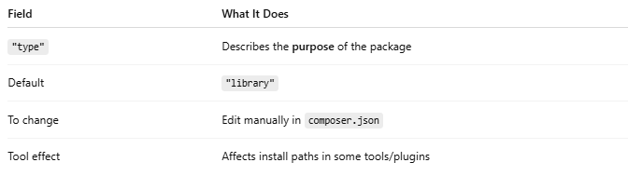
Field | What It Does
"type" | Describes the purpose of the package
Default | "library"
To change | Edit manually in composer.json
Tool effect | Affects install paths in some tools/plugins

6-🔧How to Change license Type
# Source: AI Source: Provided by: [Data Path: Persons Table -> ID Column: 1, Name_En Column: Motasem Essam] -> From: [ChatGPT] on [1/26/2026]
The license field in your composer.json tells others how they are allowed to use, share, and modify your code. If you want to update it after initializing your project with Composer, here's how to do it.

✅ Step-by-Step: Change License Type

1. 📝 Open composer.json
# Source: AI Source: Provided by: [Data Path: Persons Table -> ID Column: 1, Name_En Column: Motasem Essam] -> From: [ChatGPT] on [1/26/2026]
Look for the license field:
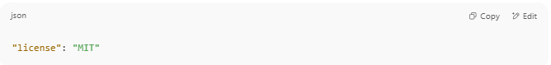
"license": "MIT"

If it doesn’t exist, you can add it manually near the top of the file.

2. ✏️ Replace or Update It
# Source: AI Source: Provided by: [Data Path: Persons Table -> ID Column: 1, Name_En Column: Motasem Essam] -> From: [ChatGPT] on [1/26/2026]
Change it to the license that matches your intent. Example:
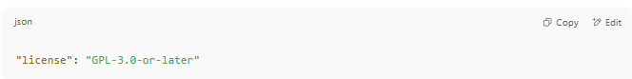
"license": "GPL-3.0-or-later"

Or:
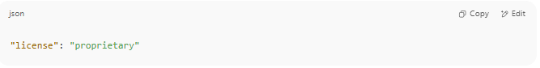
"license": "proprietary"

📋 Common License Options
# Source: AI Source: Provided by: [Data Path: Persons Table -> ID Column: 1, Name_En Column: Motasem Essam] -> From: [ChatGPT] on [1/26/2026]
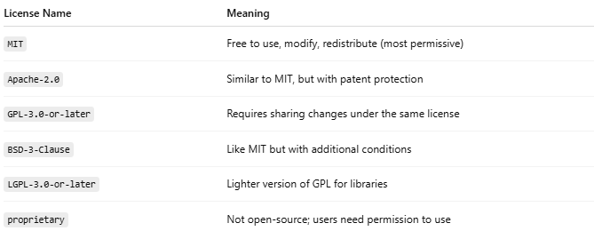
License Name | Meaning
MIT | Free to use, modify, redistribute (most permissive)
Apache-2.0 | Similar to MIT, but with patent protection
GPL-3.0-or-later | Requires sharing changes under the same license
BSD-3-Clause | Like MIT but with additional conditions
LGPL-3.0-or-later | Lighter version of GPL for libraries
proprietary | Not open-source; users need permission to use
You can check valid license identifiers at:
🔗 SPDX License List

📄 Example Before and After
# Source: AI Source: Provided by: [Data Path: Persons Table -> ID Column: 1, Name_En Column: Motasem Essam] -> From: [ChatGPT] on [1/26/2026]
Before:
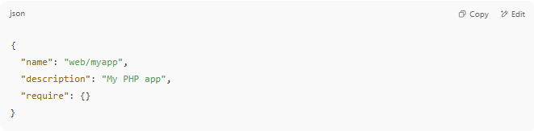
{
"name": "web/myapp",
"description": "My PHP app",
"require": {}
}

After:
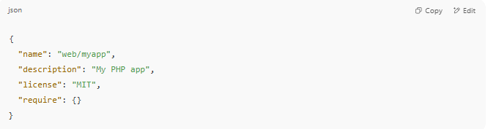
{
"name": "web/myapp",
"description": "My PHP app",
"license": "MIT",
"require": {}
}

🧠 When Should You Use proprietary?
# Source: AI Source: Provided by: [Data Path: Persons Table -> ID Column: 1, Name_En Column: Motasem Essam] -> From: [ChatGPT] on [1/26/2026]
Use "proprietary" if:
- You don’t want to share your code
- You’re working on a private business project
- You want to restrict distribution

✅ Summary
# Source: AI Source: Provided by: [Data Path: Persons Table -> ID Column: 1, Name_En Column: Motasem Essam] -> From: [ChatGPT] on [1/26/2026]
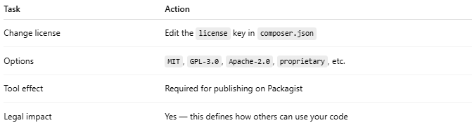

Task | Action
Change license | Edit the license key in composer.json
Options | MIT, GPL-3.0, Apache-2.0, proprietary, etc.
Tool effect | Required for publishing on Packagist
Legal impact | Yes — this defines how others can use your code

7-🔧How to Change PSR-4 Autoload Mapping
# Source: AI Source: Provided by: [Data Path: Persons Table -> ID Column: 1, Name_En Column: Motasem Essam] -> From: [ChatGPT] on [1/26/2026]
When you run composer init, you may define PSR-4 autoloading for your PHP classes. If you want to change or update the mapping later, you can easily do that by editing composer.json.

📦 What is PSR-4 Autoload Mapping?
# Source: AI Source: Provided by: [Data Path: Persons Table -> ID Column: 1, Name_En Column: Motasem Essam] -> From: [ChatGPT] on [1/26/2026]
PSR-4 maps namespaces to folders, so Composer can autoload classes automatically when you use them.
Example:
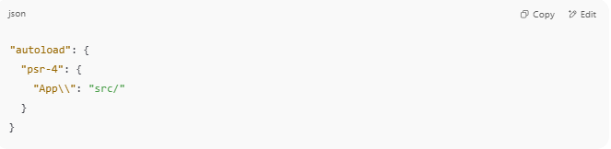
"autoload": {
"psr-4": {
"App\\": "src/"
}
}

This tells Composer:
🔁 App\Controllers\UserController → src/Controllers/UserController.php

✅ How to Change It

✏️ Step 1: Open composer.json
# Source: AI Source: Provided by: [Data Path: Persons Table -> ID Column: 1, Name_En Column: Motasem Essam] -> From: [ChatGPT] on [1/26/2026]
Look for the "autoload" section:
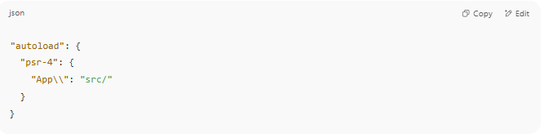
"autoload": {
"psr-4": {
"App\\": "src/"
}
}

✏️ Step 2: Change the Namespace or Folder
# Source: AI Source: Provided by: [Data Path: Persons Table -> ID Column: 1, Name_En Column: Motasem Essam] -> From: [ChatGPT] on [1/26/2026]
For example, change the namespace from App\\ to MyProject\\, and the folder to app/:
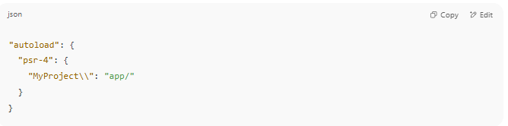
"autoload": {
"psr-4": {
"MyProject\\": "app/"
}
}

You can also add multiple mappings:
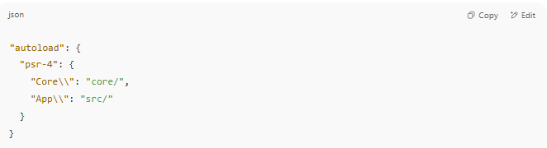
"autoload": {
"psr-4": {
"Core\\": "core/",
"App\\": "src/"
}
}

🔁 Step 3: Run composer dump-autoload
# Source: AI Source: Provided by: [Data Path: Persons Table -> ID Column: 1, Name_En Column: Motasem Essam] -> From: [ChatGPT] on [1/26/2026]
After changing the mapping, regenerate the autoload files:
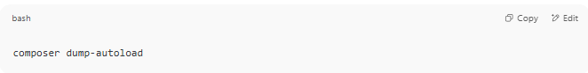
composer dump-autoload

This updates the vendor/autoload.php and makes Composer recognize your new mappings.

🧪 Step 4: Use the New Namespace in Your PHP Files
# Source: AI Source: Provided by: [Data Path: Persons Table -> ID Column: 1, Name_En Column: Motasem Essam] -> From: [ChatGPT] on [1/26/2026]
If you changed to MyProject\\, then your class should look like:
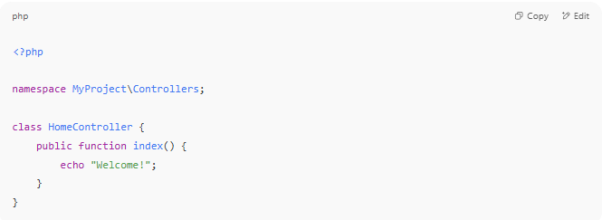
<?php

namespace MyProject\Controllers;

class HomeController {
public function index() {
echo "Welcome!";
}
}

And the file should be located at:
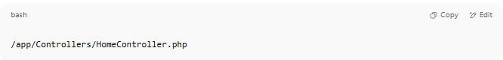
/app/Controllers/HomeController.php

✅ Summary
# Source: AI Source: Provided by: [Data Path: Persons Table -> ID Column: 1, Name_En Column: Motasem Essam] -> From: [ChatGPT] on [1/26/2026]
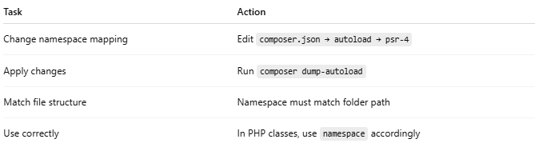
Task | Action
Change namespace mapping | Edit composer.json → autoload → psr-4
Apply changes | Run composer dump-autoload
Match file structure | Namespace must match folder path
Use correctly | In PHP classes, use namespace accordingly

Download Composer
# Source: AI Source: Provided by: [Data Path: Persons Table -> ID Column: 1, Name_En Column: Motasem Essam] -> From: [ChatGPT] on [1/26/2026]
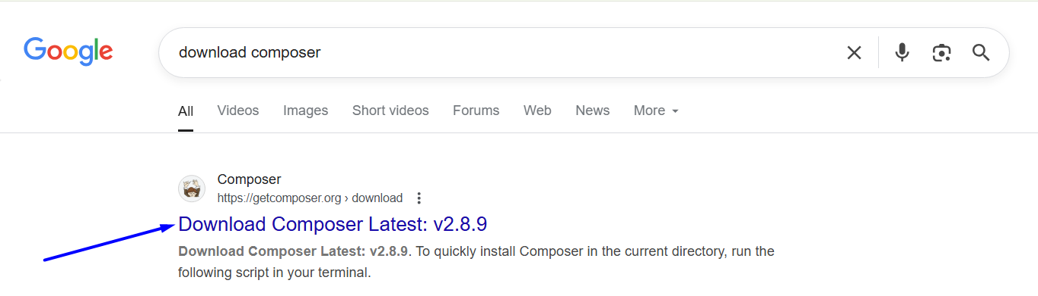

https://getcomposer.org/download/
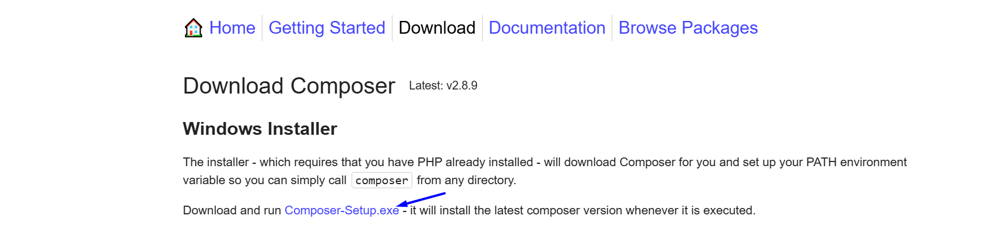

Install Composer
# Source: AI Source: Provided by: [Data Path: Persons Table -> ID Column: 1, Name_En Column: Motasem Essam] -> From: [ChatGPT] on [1/26/2026]
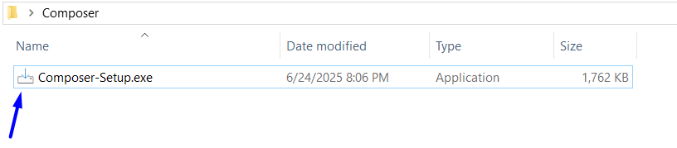
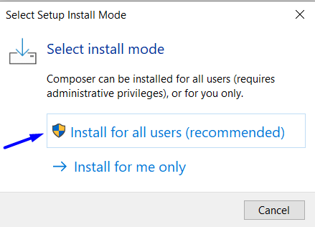
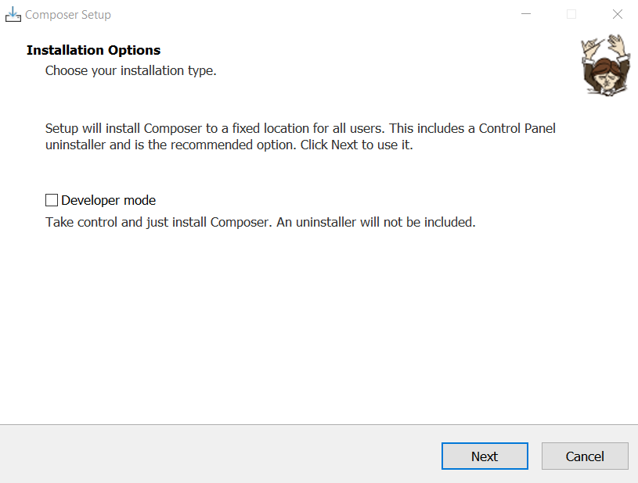
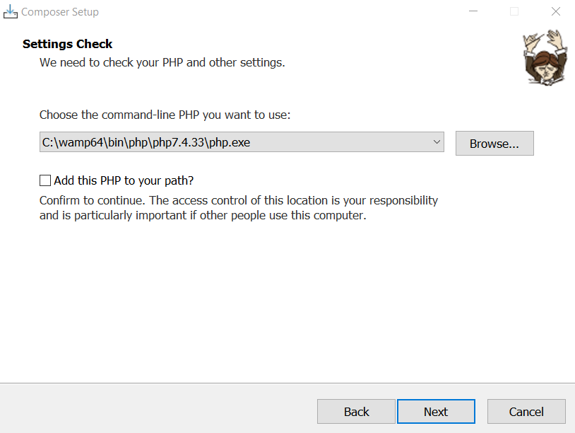
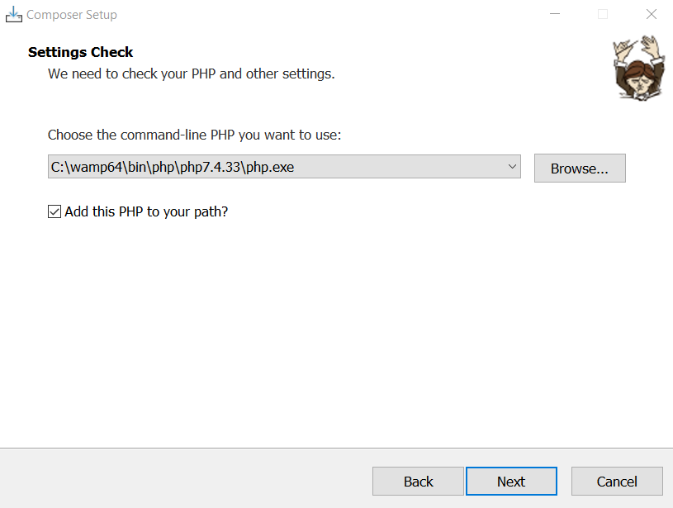
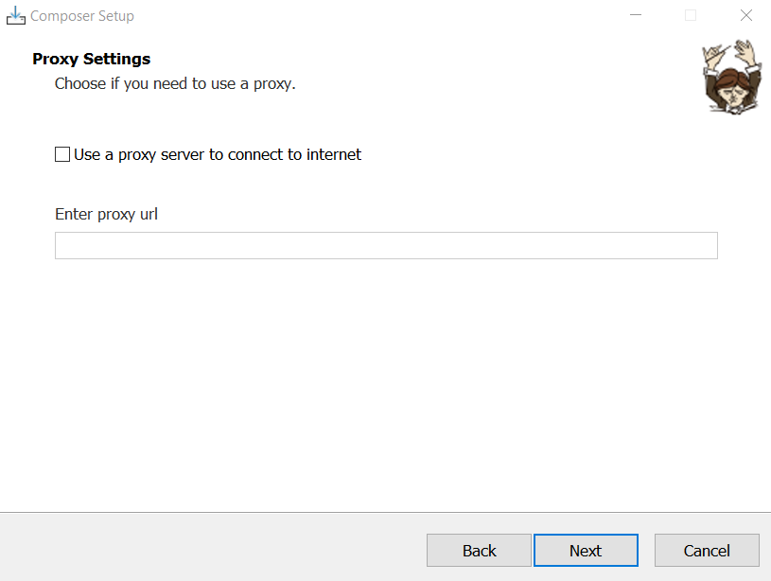
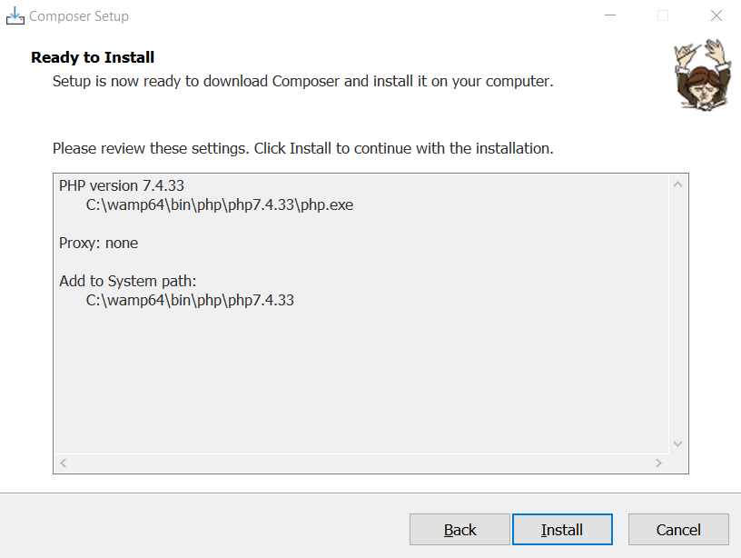
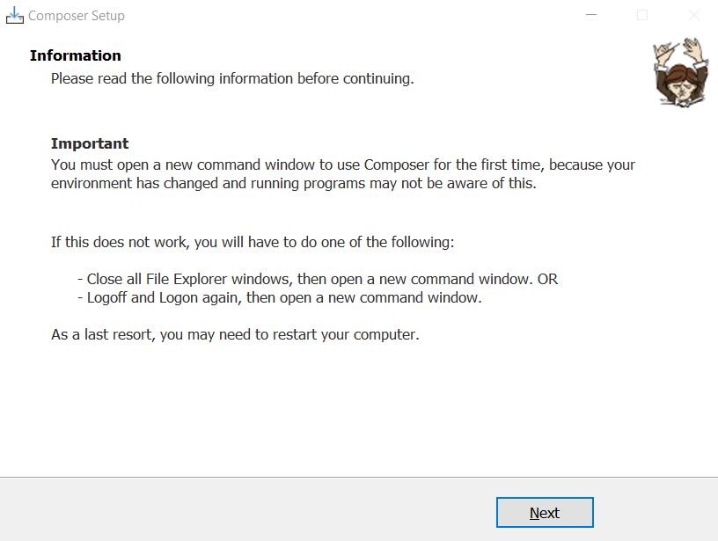
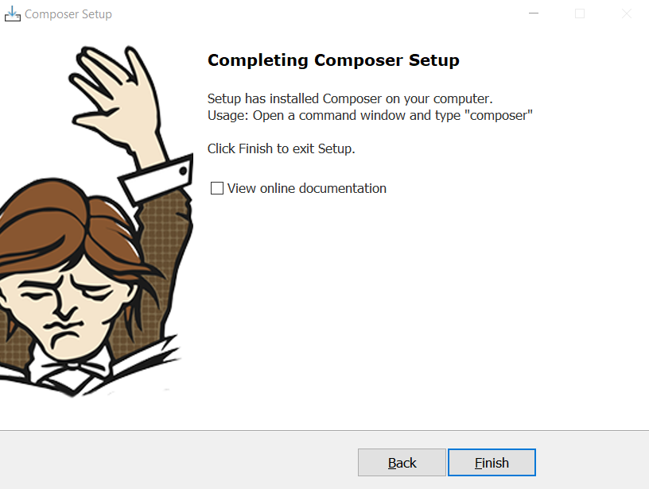

Run Composer
# Source: AI Source: Provided by: [Data Path: Persons Table -> ID Column: 1, Name_En Column: Motasem Essam] -> From: [ChatGPT] on [1/26/2026]
C:\wamp64\bin\php\php7.4.33

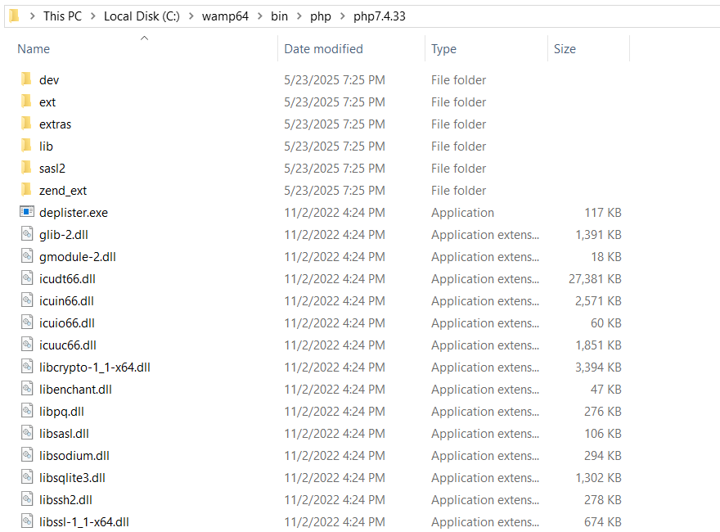
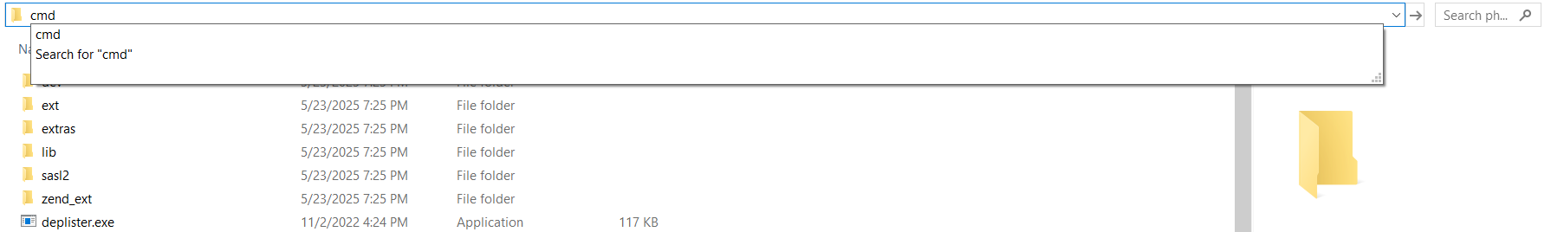
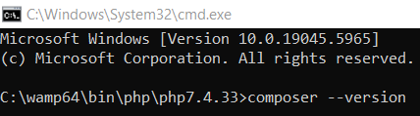
composer --version
